Relationship and sex education policy

The Haven School

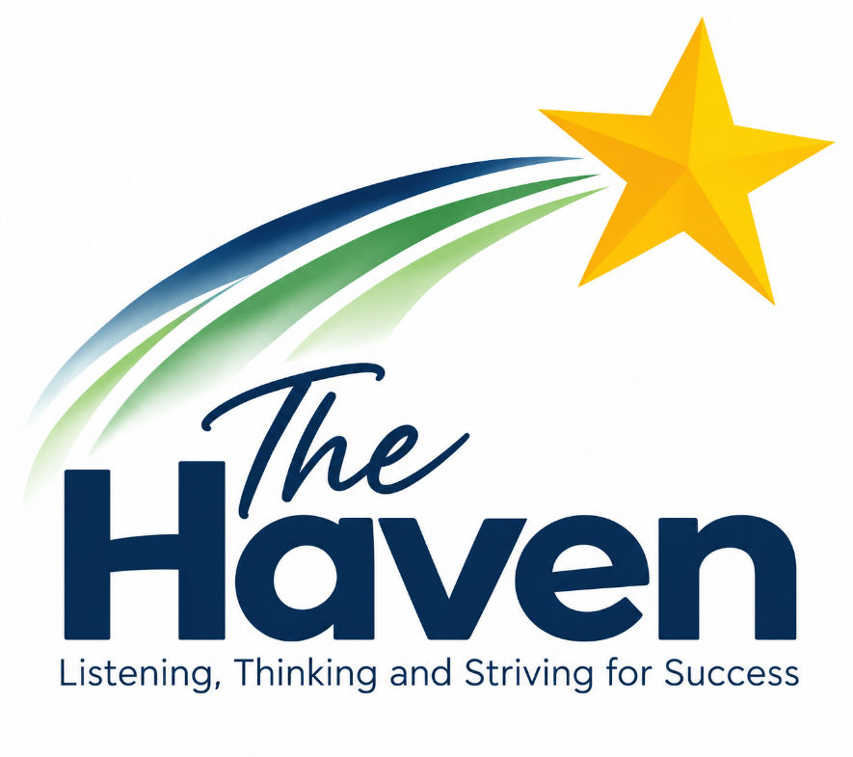

Approved by: | Victoria Jenkinson | Date: September 2026
Next review due by: | September 2027

1. Aims
The aims of relationships and sex education (RSE) at our school are to:
- Provide a framework in which sensitive discussions can take place
- Prepare pupils for puberty, and give them an understanding of sexual development and the importance of health and hygiene
- Help pupils develop feelings of self-respect, confidence and empathy
- Create a positive culture around issues of sexuality and relationships
- Teach pupils the correct vocabulary to describe themselves and their bodies

2. Statutory Requirements

The Haven School is an independent specialist school and provides Relationships Education to pupils receiving primary education and Relationships and Sex Education (RSE) to pupils receiving secondary education, in accordance with the requirements of the Education (Independent School Standards) Regulations 2014, as amended by the Relationships Education, Relationships and Sex Education and Health Education (England) Regulations 2019.

In developing and delivering our Relationships Education and RSE curriculum, we have regard to the Department for Education's Relationships Education, Relationships and Sex Education (RSE) and Health Education: Statutory Guidance, which came into force on 1 September 2026.

We also have regard to the relevant legal duties and requirements set out in:

Education Act 1996, including sections 403, 406 and 407;

Education Act 2002, including section 80A;

Education (Independent School Standards) Regulations 2014, particularly paragraph 2A concerning Relationships Education and Relationships and Sex Education;

Equality Act 2010, including Part 6 and the Public Sector Equality Duty under section 149;

the requirement to promote respect for the protected characteristics and to ensure that teaching does not unlawfully discriminate against pupils.

As an independent school, The Haven School is not required to have regard to the statutory guidance on health education; however, we may draw on this guidance where appropriate to support our wider curriculum and pupils' personal development.

Our RSE policy is kept up to date, is developed with regard to the needs of our pupils, and is made available to parents and carers on the school website.

3. Definition
RSE is about the emotional, social and cultural development of pupils, and involves learning about relationships, sexual health, sexuality, healthy lifestyles, diversity and personal identity.
RSE involves a combination of sharing information, and exploring issues and values.
RSE is not about the promotion of sexual activity.

4. Curriculum

We have developed the curriculum in consultation with pupils and staff, and taking into account the age, developmental stage, learning needs and feelings of our pupils. If pupils ask questions outside the scope of this policy, teachers will respond in an appropriate manner so that pupils are fully informed and don’t seek answers online.
We will share all curriculum materials with parents and carers upon request.

5. Delivery of RSE
RSE is taught within the personal, social, health and economic (PSHE) education curriculum. Biological aspects of RSE are taught within the science curriculum, and other aspects are included in tutor periods.

RSE focuses on giving young people the information they need to help them develop healthy, nurturing relationships of all kinds including:
- Families
- Respectful relationships, including friendships
- Online and media
- Being safe
- Intimate and sexual relationships, including sexual health.

These areas of learning are taught within the context of family life, taking care to make sure that there is no stigmatisation of children based on their home circumstances (families can include single parent families, LGBT parents, families headed by grandparents, adoptive parents and foster parents/carers, amongst other structures), along with reflecting sensitively that some children may have a different structure of support around them (for example, looked-after children or young carers).
We will also be mindful of the law and legal requirements, taking care not to condone or encourage illegal political activity, such as violent action against people, criminal damage to property, hate crime, terrorism or the illegal use of drugs.

5.1 Inclusivity
- At The Haven School, we recognise the unique and complex needs of our learners, many of whom have experienced significant challenges and trauma. Our approach to Relationships and Sex Education (RSE) is carefully tailored to ensure it is accessible, inclusive, and sensitive to the diverse backgrounds, experiences, and emotional development of our pupils.
- We are committed to delivering RSE in a way that is trauma-informed, developmentally appropriate, and flexible in its delivery. This includes adapting language, pacing, and content to suit individual learning styles and emotional readiness. We create a safe, respectful, and supportive learning environment where pupils feel empowered to engage, ask questions, and build healthy relationships.
We also work in partnership with families, carers, and external professionals to ensure that our RSE curriculum reflects and respects the values, identities, and cultural backgrounds of all members of our school community.

We will also:
- Make sure that pupils learn about these topics in an environment that’s appropriate for them, for example in:
  - A whole-class setting
  - Small groups or targeted sessions
  - 1-to-1 discussions
  - Digital formats
- Give careful consideration to the level of adaption needed

5.2 Use of resources
Primarily, we use resources from the PSHE Association and others recommended by the Local Authority PSHE team. In other cases we ensure that resources are:
  - Are aligned with the teaching requirements set out in the statutory RSE guidance
  - Would support pupils in applying their knowledge in different contexts and settings
  - Are age-appropriate, given the age, developmental stage and background of our pupils
  - Are evidence-based and contain robust facts and statistics
  - Fit into our curriculum plan
  - Are from credible sources
  - Are compatible with effective teaching approaches
  - Are sensitive to pupils’ experiences and won’t provoke distress
  - Are modified to suit the learning and emotional needs of the pupils’

6. Use of external materials

We will make sure that any agency and any materials used are appropriate and in line with our legal duties around political impartiality. It should be noted that it is unlikely we will use external speakers, given the nature of our school.
The school remains responsible for what is said to pupils. This includes making sure that any speakers, tools and resources used don’t undermine the fundamental British values of democracy, the rule of law, individual liberty, and mutual respect and tolerance of those with different faiths and beliefs.
We won’t, under any circumstances:
- Work with external agencies that take or promote extreme political positions
- Use materials produced by such agencies, even if the material itself is not extreme

7. Roles and responsibilities
7.1 The Management Board
The governing board will approve the RSE policy, and hold the headteacher to account for its implementation.
7.2 The headteacher
The headteacher is responsible for ensuring that RSE is taught consistently across the school, for sharing resources and materials with parents and carers, and for managing requests to withdraw pupils from components of RSE (see section 9).
7.3 Staff
Staff are responsible for:
- Delivering RSE in a sensitive way
- Modelling positive attitudes to RSE
- Monitoring progress
- Responding to the needs of individual pupils
- Responding appropriately to pupils whose parents/carers wish them to be withdrawn from components of RSE
Staff do not have the right to opt out of teaching RSE. Staff who have concerns about teaching RSE are encouraged to discuss this with the headteacher.
7.4 Pupils
Pupils are expected to engage fully in RSE and, when discussing issues related to RSE, treat others with respect and sensitivity. However, for some pupils this is not possible and we need to re-think our approach with them and then deliver in a different way or delay delivery until they are ready/able to engage more effectively.

8. Parents’ right to withdraw
Parents/carers have the right to withdraw their child from components of sex education within PSHE lessons up to and until 3 terms before the child turns 16. After this point, if the child wishes to receive sex education rather than being withdrawn, the school will arrange this.
Requests for withdrawal should be put in writing using the form found in Appendix 2 of this policy and addressed to the headteacher.
A copy of withdrawal requests will be placed in the pupil’s educational record. The headteacher will discuss the request with parents/carers and take appropriate action.
Alternative school work will be given to pupils who are withdrawn from sex education.

9. Training
Staff are trained on the delivery of RSE as part of their induction and it is included in our continuing professional development calendar.
The headteacher will also invite visitors from outside the school, such as school nurses or sexual health professionals, to provide support and training to staff teaching RSE.

10. Monitoring arrangements
The delivery of RSE is monitored by SLT through planning scrutiny and learning walks.
Pupils’ development in RSE is monitored by class teachers as part of our internal assessment systems.

Appendix 1: By the end of secondary school pupils should know
Topic | Pupils should know
Families | - That there are different types of committed, stable relationships  - How these relationships might contribute to human happiness and their importance for bringing up children  - What marriage is, including their legal status, e.g. that marriage carries legal rights and protections not available to couples who are cohabiting or who have married, for example, in an unregistered religious ceremony  - Why marriage is an important relationship choice for many couples and why it must be freely entered into  - The characteristics and legal status of other types of long-term relationships  - The roles and responsibilities of parents/carers with respect to raising of children, including the characteristics of successful parenting  - How to: determine whether other children, adults or sources of information are trustworthy: judge when a family, friend, intimate or other relationship is unsafe (and to recognise this in others’ relationships); and, how to seek help or advice, including reporting concerns about others, if needed
Respectful relationships, including friendships | - The characteristics of positive and healthy friendships (in all contexts, including online) including: trust, respect, honesty, kindness, generosity, boundaries, privacy, consent and the management of conflict, reconciliation and ending relationships. This includes different (non-sexual) types of relationship  - Practical steps they can take in a range of different contexts to improve or support respectful relationships  - How stereotypes, in particular stereotypes based on sex, gender, race, religion, sexual orientation or disability, can cause damage (e.g. how they might normalise non-consensual behaviour or encourage prejudice)  - That in school and in wider society they can expect to be treated with respect by others, and that in turn they should show due respect to others, including people in positions of authority and due tolerance of other people’s beliefs  - About different types of bullying (including cyberbullying), the impact of bullying, responsibilities of bystanders to report bullying and how and where to get help  - That some types of behaviour within relationships are criminal, including violent behaviour and coercive control  - What constitutes sexual harassment and sexual violence and why these are always unacceptable  - The legal rights and responsibilities regarding equality (particularly with reference to the protected characteristics as defined in the Equality Act 2010) and that everyone is unique and equal
Online and media | - Their rights, responsibilities and opportunities online, including that the same expectations of behaviour apply in all contexts, including online  - About online risks, including that any material someone provides to another has the potential to be shared online and the difficulty of removing potentially compromising material placed online  - Not to provide material to others that they would not want shared further and not to share personal material which is sent to them  - What to do and where to get support to report material or manage issues online  - The impact of viewing harmful content  - That specifically sexually explicit material e.g. pornography presents a distorted picture of sexual behaviours, can damage the way people see themselves in relation to others and negatively affect how they behave towards sexual partners  - That sharing and viewing indecent images of children (including those created by children) is a criminal offence which carries severe penalties including jail  - How information and data is generated, collected, shared and used online
Being safe | - The concepts of, and laws relating to, sexual consent, sexual exploitation, abuse, grooming, coercion, harassment, rape, domestic abuse, forced marriage, honour-based violence and FGM, and how these can affect current and future relationships  - How people can actively communicate and recognise consent from others, including sexual consent, and how and when consent can be withdrawn (in all contexts, including online)
Intimate and sexual relationships, including sexual health | - How to recognise the characteristics and positive aspects of healthy one-to-one intimate relationships, which include mutual respect, consent, loyalty, trust, shared interests and outlook, sex and friendship  - That all aspects of health can be affected by choices they make in sex and relationships, positively or negatively, e.g. physical, emotional, mental, sexual and reproductive health and wellbeing  - The facts about reproductive health, including fertility and the potential impact of lifestyle on fertility for men and women  - That there are a range of strategies for identifying and managing sexual pressure, including understanding peer pressure, resisting pressure and not pressurising others  - That they have a choice to delay sex or to enjoy intimacy without sex  - The facts about the full range of contraceptive choices, efficacy and options available  - The facts around pregnancy including miscarriage  - That there are choices in relation to pregnancy (with medically and legally accurate, impartial information on all options, including keeping the baby, adoption, abortion and where to get further help)  - How the different sexually transmitted infections (STIs), including HIV/AIDs, are transmitted, how risk can be reduced through safer sex (including through condom use) and the importance of and facts about testing  - About the prevalence of some STIs, the impact they can have on those who contract them and key facts about treatment  - How the use of alcohol and drugs can lead to risky sexual behaviour  - How to get further advice, including how and where to access confidential sexual and reproductive health advice and treatment

Appendix 2: Parent/carer form: withdrawal from sex education within RSE

To be completed by parents/CARERS
Name of child |  | Class
Name of parent/carer |  | Date
Reason for withdrawing from sex education within relationships and sex education
Any other information you would like the school to consider
Parent signature

To be completed by the school
Agreed actions from discussion with parents/carers

