The Haven Special Educational Needs and Disability (SEND) Policy

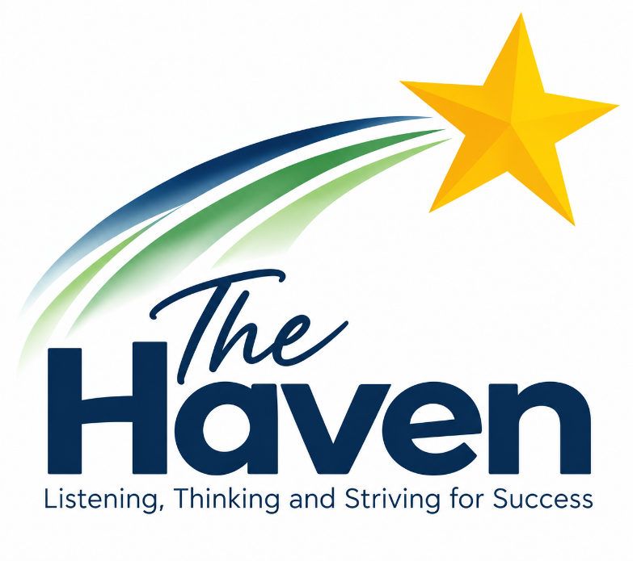

Author | Victoria Jenkinson
Version | 1.0
Creation Date | September 2026
Last Edited | First Edition
Last Editor | N/A
Company Director Review Date | September 2026
Company Director Review By | John Anderson
Next Review Date | September 2027

Introduction and Aims of this Policy
SEND is the responsibility of all staff at The Haven School. All staff are kept up to date with statutory requirements, expectations, and best practice through a robust training programme that includes regular CPD sessions, weekly teaching and learning briefings, and ongoing supervision and input from our clinical psychologist.
Our SEND policy sets out how we meet our statutory responsibilities under the Children and Families Act (2014) and the SEND Code of Practice (2015). It is designed to ensure high standards of provision and positive outcomes for every student.
This policy underpins the practice at The Haven School and supports our mission to provide a safe, nurturing, and trauma-informed learning environment for all students. The aims of this policy are to:
- Provide a safe, nurturing, and trauma-informed learning environment where students feel secure and supported.
- Ensure all pupils make the best possible progress, both academically and emotionally, in ways that reflect their individual needs.
- Actively involve parents, carers, and pupils in planning, monitoring, and reviewing educational provision.
- Equip all staff with high-quality training, resources, and ongoing support to meet the diverse needs of our learners.
- Foster close working relationships with health, social care, and external professionals to ensure holistic and coordinated support.
- Prepare students for successful transitions at each stage, including post-16 education, training, or employment.
- Promote inclusive practice through Quality First Teaching and adaptive approaches in every classroom.

School Context
The Haven School is an independent special school catering to pupils aged 11 to 18, all of whom have Education, Health and Care Plans (EHCPs). Our students often have complex life experiences involving trauma or attachment difficulties and may have diagnoses such as Attention Deficit Hyperactivity Disorder (ADHD) or Autism Spectrum Condition (ASC). Some pupils also present with secondary needs related to cognition and learning or communication and interaction. In addition, we recognise that some students may have physical, sensory, or medical needs, and where appropriate, we work closely with specialist services to ensure they have full access to learning and life opportunities.
We aim to build a sense of community and belonging, and to offer new opportunities to learners who may have experienced previous difficulties. This does not mean that we will treat all learners in the same way, but that we will respond to learners in ways which take account of their varied life experiences and needs.
Students come to The Haven from other special schools, mainstream schools, and after being home tutored or out of school for extended periods. Our mission is to transform school into a positive experience and to prepare young people for further education, employment, or training.
Our Relational Approach
At The Haven School, we prioritise relationships as the foundation for all learning and development. We recognise that secure, trusting adult-student relationships are central to emotional regulation, resilience, and engagement—particularly for pupils with a history of trauma, disrupted attachments, or social, emotional and mental health (SEMH) needs. Our relational approach is rooted in principles of trauma-informed care, co-regulation, and unconditional positive regard. Staff model calm, consistent, and compassionate behaviour, using strategies such as relational gestures, emotional coaching, and restorative conversations to maintain connection even during times of crisis. We actively avoid punitive responses and instead foster a sense of safety, belonging, and mutual respect. This enables students to feel seen, valued, and supported as they rebuild their capacity for trust, emotional literacy, and meaningful learning.

Consulting and Involving Parents and Pupils
For children with an EHCP, parents have the right to request a particular school, and the Local Authority must comply with that preference and name the school or college in the EHCP unless it would be unsuitable for the age, ability, aptitude or SEN of the child or young person, or if the placement would be incompatible with the efficient use of resources.
Before securing a placement at The Haven, the Local Authority must consult the Head-teacher and send a copy of the EHCP or draft EHCP. The Head-teacher, clinical psychologist, and governing body work collaboratively to determine whether the school can meet the identified needs of the child. If a draft EHCP includes provision funded by a personal budget, the Local Authority must also seek the school's agreement for delivery on the premises.
It is vital that The Haven and families work in partnership to meet the needs of our students. We operate an open-door policy and encourage regular, open communication between home and school. Each pupil is allocated a keyworker who maintains weekly contact with parents and carers to discuss progress, provision, and any required timetable adaptations.
Pupils are actively involved in shaping their educational experience through keyworker discussions and by participating in target-setting within their Haven Star Learning Plans and careers pathway documents. They also contribute their views during annual reviews to ensure their voices inform decision-making. Where families require additional support, they are invited to structured sessions with our clinical psychologist.

Curriculum and Provision
At The Haven, our curriculum is designed to inspire pupils to re-engage with learning and equip them with the knowledge, skills, and resilience they need for life beyond school. Grounded in trauma-informed practice and attachment-aware principles, our curriculum balances academic, personal, and social development.
All pupils follow a personalised programme that reflects their EHCP outcomes, strengths, and needs. Some will follow an Engagement Pathway where the focus is rebuilding of trust in the education process and developing key life/learning skills. Some students will focus more on academic and creative subjects, which are interweaved with therapeutic and social elements.
Timetables will feature elements drawn from the following:
- Broad and Balanced Learning: Students can access a wide range of academic and creative subjects including English, maths, science, art, PE, humanities, computing, PSHE, Psychology, Health and Social Care, and Film Studies. Qualifications range from Entry Level and Functional Skills to GCSEs and BTECs.
- Therapeutic and Social Curriculum: Emotional wellbeing is embedded throughout the day. Daily routines (e.g. breakfast club, keyworker mentoring), targeted support, and therapeutic input (including from our clinical psychologist and wellbeing team) ensure students have the right support when needed.
- Disciplinary Literacy. Literacy is taught across all subjects, and we use innovative technology like Lexplore and Lexia to track progress and identify needs.
- Cultural Capital and Enrichment: Offsite learning experiences such as farming, working with horses, land skills, craft, and outdoor education enhance engagement and broaden students’ horizons. Pupils also have opportunities to take part in team tournaments, including cricket and football, which promote teamwork, confidence, and a sense of achievement.
- Curriculum Pathways: Students follow either an engagement or main cohort pathway, based on individual needs. Pathways are reviewed regularly to ensure students are supported to progress academically, socially, and emotionally.
- Preparation for Adulthood: Careers education, work experience, and independent careers guidance are integrated throughout Key Stage 4 and post-16 to ensure all students are well prepared for their next steps.
Progress across the curriculum is tracked using our Haven Star assessment system, which evaluates development across five core personal and learning capacities: confidence, determination, communication, resilience, and learning. This system ensures that our curriculum values not only academic achievement but also meaningful progress towards the social and emotional outcomes identified in each student's EHCP. It also supports pupils to develop the essential life skills they will need beyond their time at The Haven

How We Teach Pupils with SEND at The Haven
At The Haven, all teachers are responsible for delivering high-quality, inclusive education through the principles of Quality First Teaching (QFT), and they regularly receive training on adaptive teaching techniques. Our approach ensures that every pupil, regardless of their special educational needs or disabilities, has access to a supportive, engaging, and challenging learning environment.
Students are taught in small groups of 2–5 depending on their level of need. This enables teachers to differentiate the level and pace of work effectively and ensure that support from Teaching Assistants is matched appropriately.
Adaptive teaching at The Haven involves making deliberate adjustments to teaching methods, resources, and the learning environment in response to students’ individual needs and starting points. This includes pre-teaching key vocabulary, providing scaffolded tasks, using assistive technology, offering multi-sensory approaches to learning, and modifying questioning to support understanding and promote independence. These strategies ensure that pupils can engage meaningfully with lesson content while building confidence and self-regulation.
Staff at The Haven contribute to teaching and learning through collaborative planning, daily briefings, and regular reviews of pupils’ profiles, where successful strategies are shared. Through positive, trusting relationships, frequent feedback, and high expectations, students are empowered to succeed academically and emotionally within a nurturing, trauma-informed environment.

How we support Literacy
The Haven recognises that literacy difficulties can present a significant barrier to learning and may be closely linked with pupils’ wider SEND, including SEMH and ASC needs. Previous experiences of difficulty or failure in reading, writing or communication may contribute to anxiety, avoidance, reduced confidence or disengagement.
Pupils’ literacy needs are therefore considered as part of a personalised and trauma-informed approach to teaching and support. Staff are expected to identify the barriers that may prevent an individual pupil from accessing reading, writing, speaking or listening tasks and to make appropriate adaptations while maintaining high expectations.
Adaptations may include reduced cognitive load, chunking, modelling, visual support, pre-teaching vocabulary, reading aloud, audio resources, scaffolded writing, sentence starters, structured questioning, additional processing time, alternative methods of demonstrating understanding and assistive technology where appropriate.
Reading ability is assessed as close to a pupil’s start date as possible in order to establish individual starting points and identify areas of need. A range of information may be used, including teacher assessment, Lexplore, reading age information, comprehension assessment, pupil voice, previous educational information and observations of reading confidence and behaviour.
Where additional support is required, pupils may access targeted intervention such as phonics, decoding, fluency, vocabulary, comprehension, supported reading, Lexia, individual intervention or small-group support. Intervention is reviewed regularly to consider its impact and identify next steps.
Literacy needs and progress may also be considered through pupil progress meetings, PEPs, EHCP reviews and intervention planning. Support should be designed to increase pupils’ independence over time and enable them to access the curriculum, qualifications, further education, employment and adult life. (see school literacy strategy)

Access Arrangements and Equal Opportunities
The Haven School adheres to JCQ regulations for access arrangements, ensuring students can demonstrate their learning in a way that suits their usual method of working. Arrangements may include the use of readers, scribes, word processors, extra time, or adapted environments. These are regularly reviewed in line with teaching observations and formal assessments to ensure fairness and accessibility for all. Access arrangements are a key part of our commitment to equality and inclusion.

Supporting Transitions and Preparation for Adulthood
Careers education is taught explicitly through our PSHE curriculum. Additional guidance and support are provided through keyworker sessions, assemblies, and regular meetings to discuss next steps with students. Each year, KS4 students also attend the NEC Careers Fair, and Sixth Form students have opportunities to participate in appropriate work experience placements tailored to their needs and interests.
We maintain close links with specialist colleges and offer bespoke transition activities to prepare pupils for their next steps. For more information, please refer to our separate Careers Policy.

Role of the SENCo
The Special Educational Needs Coordinator (SENCo) at The Haven School is a qualified teacher responsible for overseeing the day-to-day operation of the SEND policy. The SENCo ensures that the needs of all pupils with special educational needs are met effectively by coordinating provision, monitoring the impact of interventions, and liaising with external professionals and agencies. The SENCo plays a key role in the development of inclusive teaching practices across the school and is responsible for ensuring that statutory duties outlined in the SEND Code of Practice (2015) are adhered to. This includes maintaining up-to-date records of provision and outcomes, supporting staff with strategies and resources, and ensuring effective communication with families. The SENCo contributes to the strategic development of SEND provision within the school and provides termly updates to senior leaders and governors.

Expertise and Training of Staff
Staff at The Haven School are provided with comprehensive professional development to ensure they can meet the complex needs of our pupils. Regular CPD includes training on attachment, literacy difficulties, and Non-Violent Resistance (NVR) Weekly briefings offer ongoing opportunities to share best practice. New staff undergo a thorough induction covering therapeutic models, safeguarding procedures, trauma-informed practice, EHCP understanding, and adaptive teaching strategies. All staff receive support and supervision from the in-house clinical psychologist.

Annual Reviews
Each EHCP is formally reviewed at least annually, with participation from parents, carers, students, staff, and relevant external professionals. These reviews focus on:
- Progress towards EHCP outcomes
- Attainment in key areas such as literacy and numeracy
- Any new or ongoing difficulties since the last review
- What is working well and what is not
- Future aspirations and next steps
- Social, emotional, or behavioural progress and challenges
- Health or social care needs
- Any necessary modifications to the curriculum or learning environment
- Recommended amendments to the EHCP (if appropriate)
The outcomes of the Annual Review are used to update Learning Plans and inform planning for teaching, interventions, and access arrangements
Where necessary, additional mid-year reviews are conducted to reflect changes in circumstances or emerging needs. Students are supported to contribute actively to the review process.
The Annual Review also considers whether the current provision remains appropriate and makes recommendations to the Local Authority if changes to the EHCP or funding arrangements are required.

Monitoring and Accountability
All staff at The Haven School are required to read this SEND Policy and confirm, by signing, that they have understood and accepted their responsibilities. This is in accordance with Section 6 of the SEND Code of Practice, which outlines statutory duties for schools. The delivery and impact of SEND provision is closely monitored as part of the school’s improvement planning. All staff are expected to deliver Quality First Teaching and reflect on their practice. Monitoring includes classroom observations, planning reviews, and CPD tracking. Staff feedback and pupil voice contribute to ongoing development of practice and provision. The school works in partnership with families and external agencies to ensure accountability and continuous improvement.

Complaints
Concerns about SEND provision should initially be discussed with the class teacher or SENCO. If further resolution is required, the Headteacher can be contacted. Formal complaints will be managed in line with the school’s Complaints Policy.
Next Review Due: June 2026

