The Haven School

Provider Access Policy Statement

(To include The Department of Education, July 2021: “Baker Clause” and the Provider Access Legislation, January 2023)
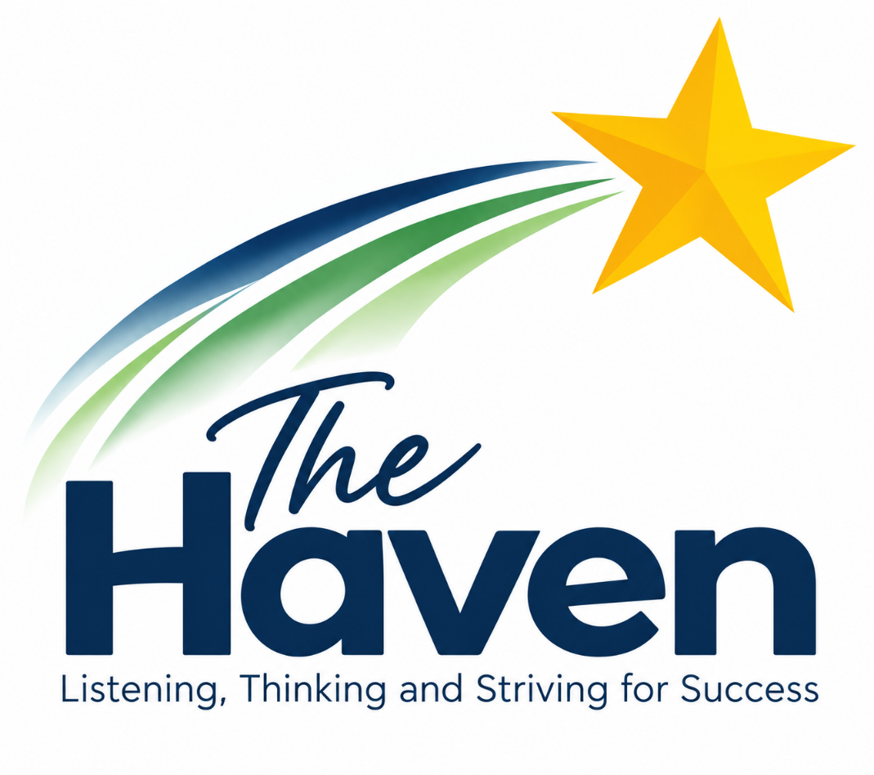

Author | Victoria Jenkinson
Version | 1.0
Creation Date | September 2026
Last Edited | First Edition
Last Editor | N/A
Company Director Review Date | September 2026
Company Director Review By | John Anderson
Next Review Date | September 2027

Rationale
High quality careers education and guidance in school or college is critical to young people’s futures. It helps to prepare them for the workplace by providing a clear understanding of the world of work including the routes to jobs and careers that they might find engaging and rewarding. It supports them to acquire the self-development and career management skills they need to achieve positive employment destinations. This helps students to choose their pathways, improve their life opportunities and contribute to a productive and successful economy.
As the number of apprenticeships rises every year, it becomes increasingly important that all young people have a full understanding of all the options available to them post-16 and post-18 including wider technical education options such as T-Levels and Higher Technical Qualifications.
Commitment
The Haven School is committed to ensuring there is an opportunity for a range of education and training providers to access students, for the purpose of informing them about approved technical education qualifications and apprenticeships. The Haven School is fully aware of the responsibility to set students on the path that will secure the best outcome which will enable them to progress in education and work and give employers the highly skilled people they need. That means acting impartially, in line with the statutory duty, and not showing bias towards any route, be that academic or technical.
The Haven School endeavours to ensure that all students are aware of all routes to higher skills and are able to access information on technical options and apprenticeships (The Department of Education, July 2021: “Baker Clause”: supporting students to understand the full range of education and training options, and the Provider Access Legislation, January 2023).
Aims
The Haven School policy for Access to other education and training providers has the following aims:
To develop the knowledge and awareness of our students of all career pathways available to them, including technical qualifications and apprenticeships.
To support young people to be able to learn more about opportunities for education and training outside of school before making crucial choices about their future options.
To reduce drop out from courses and avoid the risk of students becoming NEET (Young people not in education, employment or training).

Student Entitlement
The Haven School fully supports the statutory requirement for students to have direct access to other providers of further education training, technical training and apprenticeships. The school will comply with the new legal requirement to put on at least six encounters with providers of approved technical education qualifications or apprenticeships. This will be done in a variety of ways that support the needs of our students including, attending Career’s Fairs, assemblies in National Apprenticeship Week and National Careers Week, in addition to a variety of careers events at school/colleges or workplaces.
Development
This policy has been developed and is reviewed annually by the Careers Leader and Line Manager (Charlotte Dodd –Careers Lead and Zoie Stevenson – Headteacher) based on current good practice guidelines by the Department for Education.
Links with other policies
It supports and is underpinned by key school policies including those for Careers, Child Protection, Equality and Diversity, and SEND.
Equality and Diversity
Access to other providers is available and promoted to allow all students to access information about other providers of further education and apprenticeships. The Haven School is committed to encouraging all students to make decisions about their future based on impartial information.
Requests for access
Requests for access should be directed to Charlotte Dodd, Careers Leader. Charlotte Dodd may be contacted by telephone or email, cd@thehavenschool.com, Tel 01785 450261.
Grounds for granting requests for access
Access will be given for providers to attend during school assemblies, timetabled Careers or Life lessons, and Careers or Raising Aspirations events that The Haven School is arranging. Students may also travel to visit local colleges, work-based learning opportunities or careers fairs.
Details of premises or facilities to be provided to a person who is given access
The Haven School will provide an appropriate room or assembly hall to be agreed. All rooms have computers, projectors and screens provided. Computer rooms can also be arranged. The Careers Leader or Careers Adviser will organise this, working closely with the provider to ensure the facilities are appropriate to the audience. Appropriate safeguarding checks will be carried out. Providers will be met and supervised by a member of the Careers Team who will facilitate.
Live/Virtual encounters
The Haven School will consider live online encounters with providers where requested, and these may be broadcast into classrooms or the school assembly hall. Technology checks in advance will be required to ensure compatibility of systems.

Parents and Carers
Parental involvement is encouraged, and parents may be invited to attend the events to meet the providers.
Management
The Careers Leader coordinates all provider requests and is responsible to his/her senior management line manager.
Complaints Procedure
Any complaints about this policy should be raised to Charlotte Dodd, email: cd@thehavenschool.com
Charlotte Dodd will raise the complaint to Victoria Jenkinson, Headteacher.
Monitoring review and evaluation
The Policy is monitored and evaluated annually via the Leadership Team.
Policy Coordinator: Charlotte Dodd
Policy Reviewed: September 2027
Appendix
Providers who have either been invited into The Haven School or students have had the opportunity to visit, to date include:
Stafford College
Newcastle College
Tamworth College
MENCAP
Equality Stafford
Destinations of previous pupils from The Haven School include:
Newcastle College
Stafford College
MENCAP (supported Internship)
Equality Stafford
Sutton Coldfield College
Lichfield College
Stoke College
South Staffordshire College
Wolverhampton College

