Positive Engagement Policy
The Haven School
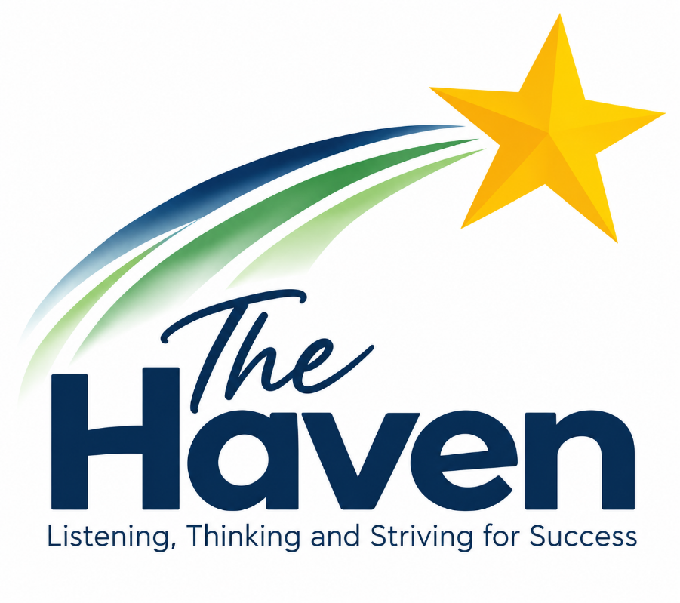

Author | Victoria Jenkinson
Version | 1.0
Creation Date | September 2026
Last Edited | First Edition
Last Editor | N/A
Company Director Review Date | September 2026
Company Director Review By | John Anderson
Next Review Date | September 2027

The Haven School Positive Engagement Policy
Introduction
The Haven school is driven by the belief that aspiration, access and achievement apply to all learners; where teachers, leaders and support professionals raise expectations to provide a system where the importance of education is understood and valued by all. The aim is to raise the aspirations of all pupils, and provide access to the best possible standard of ‘quality first’ teaching and learning that inspires; the outcome being that achievement is seen as a possibility for all.

The school genuinely believes that it can make a difference and enable children to succeed, no matter what their individual challenges or learning needs. We are committed to the creation of a nurturing teaching and learning focused environment, where the academic, social and personal needs of young people are accommodated. We aim to empower children to achieve in an ethos of safety and mutual respect, by removing barriers to learning that have been entrenched in former educational settings. Everyone is expected to behave in a reasonable way, to accept responsibility for their behaviour and to encourage others to do the same.

As a school community, we actively encourage each other to be reflective, and look closely at the impact the strategies we use have on modifying student behaviour. Staff are encouraged to embrace new research and, where appropriate, utilise this in their work. Positive outcomes that are achieved are shared and, where suitable, they are used to inform future practice.

Most systems of behaviour modification and management are based on sanction and reward. There is an increasing body of evidence to suggest that sanction of negative behavioural choice is an ineffective method of effecting change. Our approach to behavioural modification will be based on three main components.
- An effective reward system based on short, medium and long term rewards
- Curriculum modification to enhance teaching of social skills, social problem-solving skills and emotional regulation
- Intervention to ensure that post event learning opportunities are fully utilised
There will be no use of sanctions on a day-to-day basis and staff will not use language that can be associated with punitive approaches. Our interactions with pupils will be positive, avoid confrontation and promote de-escalation.

Policy Purpose
The purpose of this policy is to provide a simple, practical set of expectations for staff, learners and parent/carers which:
• Positively reinforces behavioural norms.
• Promotes self-esteem, confidence and self-discipline.
• Uses positive intervention to teach appropriate behaviour.
• Promotes an understanding of the values and vision of The Haven School

At the Haven we believe that everybody has the right to learn, to feel safe, to be respected and to be fairly treated. Pupils at the school should expect their teachers to:
- Meet them at the beginning of each lesson, ready with something appropriate to do.
- Inform them of how to be successful during the lesson.
- Share with them their progress, so that they know how they are doing and what they can do to improve.
For more information on how Teaching and Learning is used to support positive behaviour, please refer to our Teaching and learning policy.

Positive Behaviour at The Haven
The prevailing ethos is to regard prevention rather than intervention strategies as the norm. One of the most effective behaviour management strategies in schools has been shown to be careful planning which facilitates the prevention of obstacles by the prediction of potential difficulties. Preventative strategies create a context where acceptable behaviour is positively encouraged and misbehaviour is reduced. An ethos is developed which emphasises co-operation, responsibility, concern for others and self-respect.
It is evident that children prefer to learn in a relaxed yet purposeful atmosphere where they can progress academically with success and be acknowledged as ‘people who matter’, and where the adults are safely in control. We believe that when learners feel they are valued, they respect adults and accept their authority. Similarly, we recognise the implicit need for young people to develop the skills that make positive relationship with adults possible. It is critically important that staff working with pupils build strong relationships, develop high levels of personal resilience and have high expectations where the quality of learning behaviours are concerned. Staff should never ignore or attempt to excuse poor behaviour; rather they should attempt to understand its communicative intent.
A common language is used at The Haven, providing consistent responses where behaviour is unreasonable. We expect all of our Haven community to be READY, RESPECTFUL and SAFE. Our 6th form students have a slightly adjusted set of expectations, to give them more independence. These are discussed with them and they then sign to say they agree to comply.
Restorative type work and informal mediation approaches are adopted to enable children to repair and maintain any relationships that they may have damaged (see Appendix Three). Timely and clear communication between staff and families supports the management of good behaviour and promotes an effective learning environment. Routine attendance at briefings and meetings allows the staff team to make expert use of daily and weekly reports. Information sharing during the school day is also critical. Without the timely sharing of information, detailing personal events outside of the school/events that happen that day, it is harder for us to be proactive in our approach. For example, if staff members are forced to react to behaviour that might otherwise be prevented or prepared for, the outcomes can be difficult for the young person involved.

We believe that it is not always possible to respond to negative behaviour in the same way for every child, but it is useful to have a guiding framework of responses to a range of behaviours where the young person is struggling. This ensures that learners within the school can be certain that every behaviour, positive or negative, will elicit some form of adult intervention. Inappropriate behaviour is more likely to occur when learners lack a sense of purpose and/or structure, are presented with opportunities to misbehave or are struggling to deal with external factors unrelated to school. It is preferable to prevent unwanted behaviour from occurring as dealing with unacceptable behaviour wastes time, can lead to confrontation and is stressful for everyone involved. This principle is relevant to all aspects of our behavioural work, both academically and socially. Measures can and should be employed to prevent potentially damaging situations from arising.

Many of our students have not been successful in other settings, so we have to work differently to mainstream provisions/generic special schools to encourage success and minimalize the chances of failure. Strategies that we may use to support our young people when they are in crisis/dis-regulated include: shorter days, bespoke/needs-led timetables (which are reviewed weekly by SLT and where possible increased back up to full time ASAP) and outreach work. This is always done in agreement with parents or carers in the interest of getting the pupil quickly back on track.

Making Reasonable Adjustments
Sometimes situational factors that students find themselves in mean that their ability to regulate their behaviour becomes significantly hindered. A student can be making good progress with engagement and relationships, but then something happens outside school (breakdown of placement/contact (or lack of) with parents/siblings, changes to key staff working with them) and this de-stabilises them. As a school, we then make reasonable adjustments to meet their changing needs and approach the behavioural support of this young person differently for a set period of time. This approach is reviewed regularly and timescales and adjustments made shared with all stakeholders. It is at this point, more than ever, we need the full support of all professionals and the child’s parents/carers to work together, to support the young person as best we can using a holistic, child-centred approach. On these occasions, adaptations to the young person’s timetable and learning pathway are made to support them through more challenging periods.

Exclusions (for more information ref to our exclusion policy on the website)
The vast majority of behaviour is managed in school. However, there are a number of more serious behaviours that stop learners doing well and could result in exclusion or a review of their programme of study and placement. These include:
• Verbal or physical abuse of staff
• Bullying – physical, verbal, emotional
• Sexual harassment
• Prejudice on grounds of race, age, gender, sexuality, disability and others
• Carrying an offensive weapon
• Use or sale of alcohol or other mood- changing drugs
• Deliberate damage or theft of property

Missed Learning
The primary function of The Haven School is to provide outstanding educational provision thus supporting academic progress and the development of essential pro-social skills. Encouraging all pupils to attend all of the timetabled lessons.

The aim of our missed learning procedure is to reduce the number of learning opportunities lost by selective absence form lessons
To reduce the number of learning opportunities lost by selective disengagement from activities. To compensate for these losses by providing replacement learning opportunities and to give pupils the chance to reflect positively upon their decision making.

Principles
Missed Learning will be applied to students who have chosen non-attendance of lessons without them having reasonable mitigating circumstances.
It will be applied after other strategies to modify this choice of behaviour have been exhausted.

It may be applied on a compulsory basis, with the support of parents and carers. It will never be applied in a punitive way. Missed Learning is not a sanction and will not be used as a ‘threat’. The learning completed will be that which was missed and will be supported wherever possible by the subject leader. Missed Learning is intended as a tool to modify behaviour choices. Once this has happened then any outstanding missed learning may be discontinued.

APPENDIX One
Behaviour Framework
Responses to Positive Behaviour (Also see our rewards policy)
Meeting Behaviour Expectations | - Verbal praise  - Commendation awarded  - Parents/carers informed for consistent good behaviour  - Positive report sent home  - Learner of the Week Award
Helping other learners or staff/ Responding appropriately to requests to change behaviour. | As above
Meeting personal targets  Excellent Work | - Verbal praise  - Bronze/silver/gold awards  - Commendations  - Head Teacher Award  - Parents informed about excellent work/meeting with Headteacher  - Display of work around school and online

Responses to Negative Behaviour
Failing to observe The Haven School’s expectations | - Classroom management by the teacher as stated in the behaviour expectations. Verbal reminder from staff.  - Support given to become more ‘ready’ to learn  - Use of break out room/time out encouraged and supported where appropriate  - Targets set in key worker sessions  - Restorative principles applied when the young person is calm enough to reflect on behaviour
Persistent failure to observe The Haven School’s expectations | - Phone call to parents/carers  - Record on RM (school data system)  - Programme altered to meet individual need  - Ongoing risk assessment review  - Involvement of appropriate outside agencies/EHA process  - Implementation of restorative practice  - Regular access to Key worker  - 1:1 off site education/use of missed learning catch up opportunity.  - Mid-term EHCP/PEP review where relevant  - Fixed term exclusions  - Restorative principles applied
Bullying/discriminatory behaviour | - Automatic call home or staff visit  - 1:1 offsite education/use of return to learn room  - Possible fixed term exclusion depending on severity/circumstance/SEND of student  - Additional support with specific areas of PSHE curriculum- dependent on type of behaviour displayed.  - Mediation offered/encouraged  - Restorative principles applied  - Parental/multi-agency meeting  - Referral to SLT
Physical or verbal abuse of staff | As above

Positive Handling
The majority of staff are trained in positive handling developed by Intelligenca within the first 2 years of their time at The Haven if the cohort risk assessment identifies this as a training need then it will be within 1 year. This enables staff to develop a range of psychological and physiological responses to behaviour that will help minimise the potential harm that disruptive, aggressive, and/or violent behaviour can cause. Staff also gain essential, knowledge, skills and confidence to prevent, decelerate and de-escalate crisis situations which are applied in their everyday classroom practice. The intention of the Intelligenca programme is to ensure that the staff have the necessary skills to reduce the likelihood of risky or unsafe behaviours occurring. In addition to this, staff are taught how to manage such behaviour when it does occur using a range of Intelligenca positive interventions that aim to minimise risk without damaging the professional and supportive relationships that they have worked so hard to establish with the pupils. The use of any positive intervention is always used as a last resort when other techniques have failed or when a situation is deemed so dangerous that to not intervene would lead to a severe outcome.

Appendix 3 Restorative Practice
Restorative practice is an alternative way of thinking about addressing discipline and behavioural issues and offers a consistent framework for responding to these issues. The table below compares different ways of thinking and responding in authoritarian and restorative models of discipline.

Authoritarian Approaches- The focus is on: | Restorative Approaches -The focus is on:
Rule-breaking | Harm done to individuals
Blame or guilt | Responsibility and problem-solving
Adversarial processes | Dialogue and negotiation
Punishment to deter | Repair, apology and reparation
Impersonal processes | Interpersonal processes
and, as a result;  The unmet needs behind the behaviour are ignored  Accountability = being punished | and, as a result;  The needs of those affected are addressed  Accountability = putting things right

Schools that work restoratively find that relationships are stronger and learning is more effective, and so there is less need to resort to sanctions and punishments, to try to ‘manage’ behaviour. There is a shift from one model of discipline to the other.
What is a restorative response to harm or conflict? Those affected are invited to share:
1. What has happened?
2. What the impact has been on those involved: i.e. who has been affected and in what ways they have been affected.
3. What needs to happen to put things right, or to make things better in the future.

What are the key elements of Restorative Approaches?
Restorative Approaches are value–based and needs–led. They can be seen as part of a broader ethos or culture that identifies strong, mutually respectful relationships and a cohesive community as the foundations on which good teaching and learning can flourish. In such a community, young people are given a lot of responsibility for decision-making on issues that affect their lives, their learning and their experience of school.
Restorative Approaches build upon the basic principles and values of humanistic psychology:
- Genuineness - honesty, openness, sincerity.
- Positive regard for all individuals - valuing the person for who they are.
- Empathic understanding – being able to understand another’s experience.
- Individual responsibility and shared accountability.
- Self-actualisation - the human capacity for positive growth.
- Optimistic perspectives on personal development - that people can learn and can change for the better.
Such principles and values not only underpin the more formal Restorative Approaches, but they can also be practised in our informal, day-to-day interaction with others. Adults who use this ‘model’ effectively are able to build and maintain emotionally healthy relationships, and promote helpful, pro-social attitudes. In doing so, these adults may well be providing a positive ‘social learning context’ not readily available to some young people in other areas of their lives.

Appendix 4- Administration of Missed Learning
Once missed learning is applied (after discussion at staff briefing) a member of SLT would call the child home. The pupil should be notified as soon as members of SLT feel that they will be able to respond positively to the news.
Pupils will be asked to complete learning the same evening and will have the option to do so in social time/tutor time in school.

Pupils who have not completed the learning in a satisfactory manner will have the opportunity to do so on the next day. The completed work will be recorded and the work ticked off once it is complete

