Curriculum Policy
The Haven School
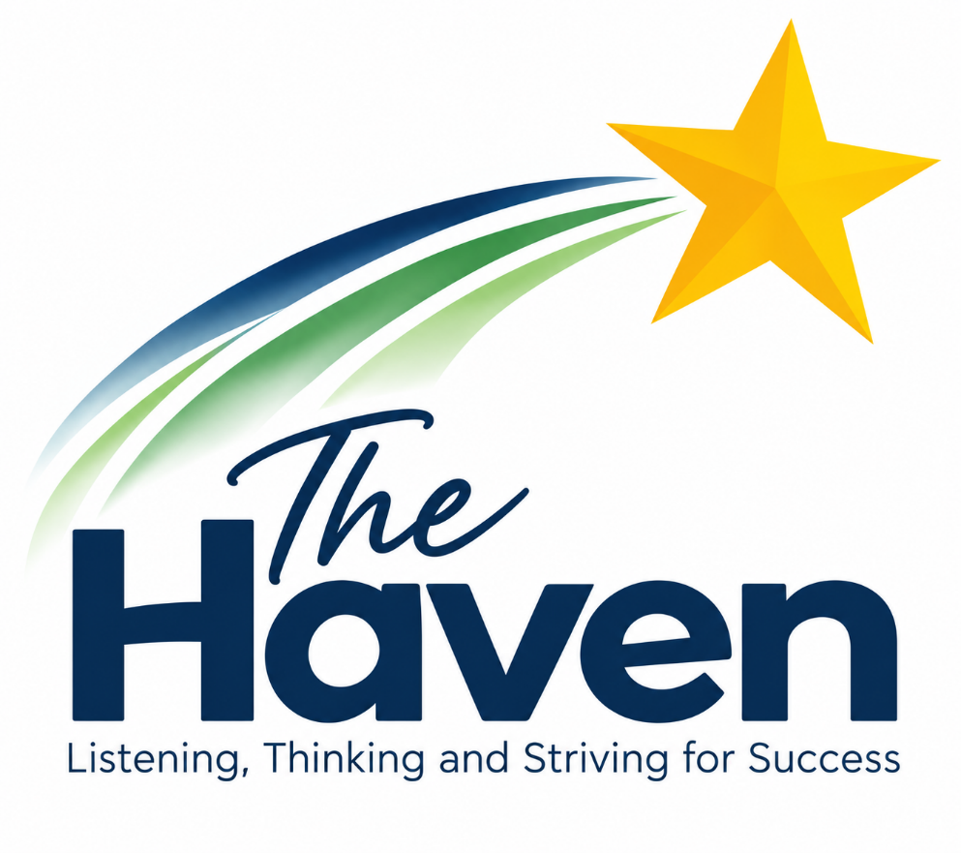

Author | Ruth O’Grady
Approved by | Victoria Jenkinson
Version | 1.0
Creation Date | September 2026
Last Edited | First Edition
Last Editor | N/A
Company Director Review Date | September 2026
Company Director Review By | John Anderson
Next Review Date | September 2027

The Haven School Curriculum Policy
Contents:
- 1. Curriculum Intent
- 2. Curriculum Overview
- 3. The Haven school social and emotional curriculum
- 4.Roles and responsibilities

Appendices
- How we work with young people at the Haven School
- Student pathways
(Please also refer to the Haven School’s Teaching and Learning Policy and Online Learning Policy)

- Curriculum Intent
Our curriculum is designed to inspire pupils to re-engage with education so they can develop the knowledge and skills they need for life beyond The Haven, as well as the resilience to tackle the challenges that life may bring.
As a Trauma Informed and Attachment Aware school, we take a relational approach to supporting pupils in managing stress and anxiety. We provide a safe, therapeutic environment where students feel understood and supported, helping them to develop essential personal skills alongside their academic potential.
At The Haven, we believe in delivering a broad and balanced curriculum so that students experience a wide range of subjects for as long as possible, along with enrichment opportunities to promote engagement, build relationships, and encourage independence. Haven Star sessions are built into the curriculum to support personal development through targeted work on communication, confidence, learning, resilience, and determination. These sessions are designed to promote independence by helping students explore their interests, build key life skills, and develop greater self-awareness. A combination of teaching skills and knowledge, the academic with the creative, and the challenging with the accessible ensures our curriculum is both engaging and inclusive. Literacy is an essential component of the Haven curriculum, and staff ensure that reading, writing, speaking and listening are embedded across all subjects.
The programme that students follow at The Haven reflects their individual needs and is informed by their Education, Health and Care Plan (EHCP). Each student has an Individual Learning Plan (ILP) and follows a Haven Star assessment pathway that enables them to achieve personal goals and make meaningful progress towards their EHCP outcomes.

- Curriculum Overview
Additional  Vocational Studies  Psychology  Sports and Fitness  Film Studies  Btec Cookery  Health and Social Care | Foundation  English  Maths  Science  ICT  Humanities  (His/Geo/RE)  Art  PE  Cooking | PSHE  Careers  Relationship  Staying Healthy  Staying Safe |  | Enrichment  (Haven Star)  Music  Horses  Tournaments  Land Skills  MMA  Outdoor Education  Gym  Arts and Crafts | Therapeutic  Yoga  Keyworker  Therapy  Wellbeing  Art  Cooking  Land Skills
Subjects  Leading to Unit award, functional skills and GCSE qualifications |  |  | Cultural Capital and British Values  Opportunities to try new experiences and explore values in society to enhance learning
Literacy Discipline
Literacy is embedded within the curriculum and enhances success in all subjects
Relationships
Positive and supportive relationships between students and staff that foster a love for leaning and self-respect.

Foundation Subjects/Accredited courses
All students at The Haven work towards nationally standardised summative assessments. Depending on ability these are at Functional Skills Level and/or GCSE Level. GCSEs In Science, students can also do entry level qualifications and students can achieve a range of AQA Unit Awards across the curriculum to help promote engagement and build self-esteem.

Key Stage 3: In Key Stage 3, pupils follow a broad and balanced curriculum that builds core knowledge, promotes curiosity, and supports the development of key life skills. Subjects include:
- English
- Mathematics
- Science
- Art
- Computing
- Physical Education (PE)
- Humanities (History RE and Geography
- Cooking
- PSHE (Personal, Social, Health and Economic Education)
This foundation allows pupils to develop confidence, resilience, and engagement with learning, while also preparing for the transition into accredited study at Key Stage 4.

Key Stage 4 : In Key Stage 4, students continue to study core subjects as part of a bespoke programme, with increasing opportunities to work towards nationally recognised qualifications. Depending on individual needs and ability, students may study for:
- Functional Skills qualifications in English, Maths, and ICT
- GCSEs, including:
  - English Language
  - Mathematics
  - Biology
  - Chemistry
  - Geography
  - Art
- BTEC qualifications in:
  - Sport
  - Health and Social Care
  - ICT
- Entry Level Certificates in Science
- AQA Unit Awards across a range of subjects, supporting engagement and building self-esteem
Our flexible approach ensures that pupils access a personalised learning pathway that supports progress towards their Education, Health and Care Plan (EHCP) outcomes and future aspirations.
Key Stage 5: Our Sixth Form offer is designed to support students as they prepare for adulthood, further education, or employment. Courses are selected based on the interests and needs of each cohort, and may include:
- BTEC Vocational Studies (core offer)
- GCSE English Literature
- GCSE Psychology
- GCSE Film Studies
- Additional Science GCSE
- AS Level Geography
The subjects offered at KS5 may vary each year to ensure they are aligned with the best interests and pathways of the students.
Personal, Social, Health and Economic education (PSHE)
PSHE threads through the whole curriculum at The Haven. All students are encouraged to access this through a variety of means including timetabled lessons, form time, assemblies and Key Worker sessions. The PSHE subject content is differentiated between key-stage 3, year 10 and year Y11. In addition to this, our Rights Respecting schools programme runs throughout the curriculum and all pupils complete a personal careers pathway document throughout their journey at the Haven (Please refer to our PSHE policy and Careers Policy for further information.)

Cultural Capital
We value experiences outside of the classroom, which are used to strengthen relationships and enhance learning. These activities help pupils develop life skills, build confidence, and support their personal and social development.
We also use enrichment opportunities to broaden pupils’ cultural understanding and deepen their subject knowledge, particularly in areas such as History and Religious Education. Visits to local historical sites and places of worship help bring these subjects to life, encouraging pupils to connect with different cultures, belief systems, and the historical context of the world around them.
Other examples of cultural enrichment include:
- Inter-school sports tournaments
- Craft workshop
- Theatre trips and workshops
- Bespoke Music sessions
- Museum visits
- Trips to National Trust properties
- Participation in careers fairs and events
These opportunities help build pupils’ cultural awareness and provide meaningful experiences that contribute to their personal development and preparation for life beyond The Haven.

British Values
At The Haven, we are committed to promoting the fundamental British values of democracy, the rule of law, individual liberty, mutual respect, and tolerance of those with different faiths and beliefs. These values are embedded throughout our curriculum, pastoral support, and whole-school ethos.
Democracy is actively promoted through our student voice, where pupils are given the opportunity to influence decisions and raise issues that matter to them. Across the curriculum, particularly in PSHE, English, science and humanities, students are encouraged to participate in debates and discussions, helping them to express their views respectfully and consider different perspectives. In the classroom, and during form time, activities such as mock elections, voting on group decisions, and role-play scenarios help to deepen students’ understanding of democratic processes in a practical and engaging way.
The rule of law is reinforced consistently throughout the school. Students learn about the importance of rules and laws that govern the classroom, the school, and wider society. This is explored through PSHE lessons, the AS Law curriculum where applicable, and through our behaviour policies, which are clearly explained and consistently applied so that students understand the expectations placed upon them. Concepts such as justice, fairness and consequences are regularly discussed through themed assemblies, and restorative practices.
Individual liberty is nurtured by providing students with opportunities to make independent and informed choices in a safe, structured environment. Keyworker sessions offer a supportive space for pupils to express their identity, explore personal challenges, and make decisions. Through the PSHE curriculum, students learn about their rights and responsibilities, and how to exercise their freedoms safely, including in relation to online safety, healthy relationships, and consent.
Mutual respect is central to our school ethos and underpins our relational approach. Staff consistently model respectful behaviours and encourage students to treat others with kindness and understanding. Our Positive Engagement Policy is built around the principles of respect and repair, supporting pupils to engage in restorative conversations when conflicts arise. Through group work, collaborative projects and mentoring opportunities, students learn to appreciate the diverse contributions, opinions and abilities of those around them.
Tolerance of different faiths and beliefs is fostered through our Religious Education (RE) and PSHE curriculum, where students explore a broad range of religions, cultures and worldviews. We encourage open dialogue and create safe spaces for students to ask questions, challenge assumptions and broaden their understanding of others. Our relational approach ensures that every pupil feels heard, valued, and safe, regardless of background or belief.

Literacy Discipline
Literacy is fundamental to pupils’ ability to access learning, communicate effectively and prepare for adulthood. At The Haven, literacy is a whole-school responsibility and is embedded across all curriculum areas rather than being viewed solely as the responsibility of the English department.
Staff receive regular training and share good practice to ensure they are explicitly teaching literacy within their subject areas. This includes helping pupils to develop the reading, writing, speaking and listening skills needed to succeed in different disciplines, for example learning to read like a scientist, write like a historian or communicate effectively within vocational and practical subjects.
Curriculum planning considers the literacy skills pupils need in order to access learning successfully, including subject-specific vocabulary, comprehension, written communication and oracy. Teaching is adapted to meet pupils’ individual starting points and needs while maintaining high expectations.
To support literacy development, The Haven uses Lexplore as a reading analysis tool to help establish pupils’ reading profiles, track progress and identify those who may benefit from targeted support. Lexia is also used as a structured intervention programme to support pupils who require additional development in areas such as decoding, fluency, vocabulary and comprehension.

- The Haven School – Social and Emotional Curriculum
As a school specialising in social, emotional and mental health needs we believe that this area of our curriculum is integral to the success of our pupils. We see our daily processes and procedures and the relationships that are formed within school as a vital part of this curriculum.
Daily Procedures
These should assist a pupil to come to school free from anxiety so that they are able to focus on learning. Pupils are received into school each morning with a warm greeting and social conversation with staff. There is a breakfast club available from 8.45 until 9.05 where pupils can have tea and toast and socialise with other pupils and staff. Break and lunch times are other opportunities to socialise and board games, as well as chess and table tennis, are available to promote easy relationship building.
Keyworker
All pupils have weekly individual mentoring sessions with their keyworker as part of their Individual Learning Plan. During these sessions, pupils are encouraged to reflect on their progress and raise any concerns they may have. Time is spent exploring career paths, work experience opportunities, learning goals, and relationship development.
As part of these sessions, Haven Star targets are set to help pupils develop their social and emotional health and work towards the outcomes identified in their Education, Health and Care Plan (EHCP). These personalised targets provide a clear focus for support and development, ensuring that progress is both meaningful and measurable.
Keyworker sessions are communicated with parents or carers on a weekly basis via a phone call or email home, to ensure consistent support between school and home.
Emotional Support
We have a chartered clinical psychologist in school one day per week. This gives plenty of time for her to work with pupils and, when desired, parents and carers. Pupils will more readily engage with the psychologist when they see her regularly and as part of the school staff. She is highly skilled at encouraging reluctant young people to discuss their thoughts and feelings and help them develop resilience.
There is a full time well-being and family support liaison in school who delivers regular wellbeing and skill-building sessions to pupils. She offers support to parents, carers and families on an individual basis; often engaging in outreach work to promote and increase attendance and put interventions in place.

Roles and responsibilities

The governing board
The governing board will monitor the effectiveness of this policy and hold the head teacher to account for its implementation.
The governing board will also ensure that:
- A robust framework is in place for setting curriculum priorities and aspirational targets
- The school is complying with its funding agreement and teaching a "broad and balanced curriculum" which includes English, maths, science, PSHE and religious education.
- All courses provided for pupils below the age of 19 that lead to qualifications, such as GCSEs and A-levels, are approved by the secretary of state
- The school implements the relevant statutory assessment arrangements

Monitoring arrangements
The senior leadership team monitor the way subjects are taught throughout the school by:
- Review of Assessment data (progress meetings where appropriate)
- Regular departmental/exams meetings
- Planning scrutinies (planning submitted half termly)
- Learning Walks and Book scrutinies
- Student Voice

Appendices A.

How we work with young people at The Haven School
The vast majority of our pupils want to behave well, learn successfully and thrive. However, their mental ill health or emotional distress interferes with this.
We use a medical model to support our pupils to improved health. This can prove more complex than when helping someone get better from a physical illness because mental ill health does not necessarily make linear progress. Sometimes we see great improvement which can be sustained for weeks or even months but then an event can occur which knocks the pupil off course again. For our young people who are looked after, this could be a change of home placement; for children who have suffered trauma or family breakdown there are multiple scenarios that can occur – the return of a long lost family member, the disappearance of a parent or another event that retriggers the trauma etc. Sometimes there is no obvious reason for the return of emotional instability. However, pupils need intensive support at these times. This is where the importance of positive relationships with staff, built up over time, can have a big impact. A pupil will often confide in a trusted adult and, by talking through their trauma, make steps towards improvement.
At these times it may be necessary to modify the programme that the pupil is following and adaptations are made to their timetable, allowing more time for calming and reducing either academic or social pressure. We are experienced in monitoring and managing emotional distress and mental ill health and work with the family and other professionals to agree steps which support the young person. Our records prove that this approach works. Some pupils who have not been to school for years remain on roll at The Haven and achieve success in examinations and move on to other educational destinations.
As with other forms of ill health, when a pupil is suffering from emotional distress, they may need time out of school to access medical appointments, or to recover enough to be able to re-engage with school. This can impact on their attendance. However, we work closely with all professionals and parents/carers to ensure pupils are back in school as soon as they are ready and able to manage. When a pupil has suffered significant distress, we may use the principle of gradual exposure to re-integrate them back into the school. This model has been successful with many of our students. Timetables are reviewed weekly, with the aim being for them to be in school, as close to full time as possible, as soon as they are able.
We do not underestimate the effort it takes for some young people to navigate their way through the school system. Emotional distress and associated issues of low self-esteem, low mood, fear of failure etc. are very hard to live with and manage. Our staff are very aware of this and our training and procedures ensure that all our young people are very well supported at The Haven.

Appendices B:
The Haven School- Student Pathways
The diagram below represents how staff use professional judgment to determine which pathway is the best fit for each student. While there are three distinct pathways, many pupils do not fit neatly into one category. In practice, students may move between pathways or follow a merged or adapted curriculum that draws on elements of more than one pathway, depending on their individual needs and circumstances.
A student does not need to meet all of the descriptors within a pathway; instead, a best-fit model is used to guide decisions. Evidence from EHCPs, discussions with parents/carers, and input from the school’s clinical psychologist all help inform the most appropriate placement. Each student’s curriculum is developed on a case-by-case basis, ensuring it is tailored to meet their specific needs, interests, and long-term goals. While the aim is for all students to progress towards the Main Cohort Pathway, this is not always possible for those with the most complex needs. In some cases, a student may move from the Main Cohort to the Engagement Pathway if they require a more therapeutic and supported environment. This might happen, for example, if there is a change in care placement, family circumstances, or a deterioration in the student’s mental or physical health.
All students on the Engagement Pathway have an Integration Plan which is reviewed weekly by SLT and monthly with all key stakeholders to ensure ongoing progress and appropriate support.

Engagement Pathway Description  Long term low attendance. Significant challenging domestic circumstances. Trauma or mental health diagnosis having a significant impact of learning. Historic low prior attainment, significant gaps in learning potentially aggressive and violent behaviour. Difficulty in making positive relationships and working in even small groups. |  | Main Cohort Pathway description  Some history of low attendance and challenging domestic issues. Trauma or mental health diagnosis having an impact on learning. In general, lower than expected academic progress has been made and there are gaps in learning. Child is starting to work in a group and displays some resilience |  | Aspire Cohort Pathway description  Pupils on the Aspire Pathway have shown improvements in their social and emotional wellbeing and are increasingly able to manage their behaviour and emotions more independently. They may have a history of low attendance or previous mental health needs, but these are now having less of an impact on their ability to engage with learning.
Engagement Pathway Priorities  Engagement pathway priorities  Improve attendance/develop relationships with key adults/develop simple learning behaviours |  | Main Cohort Pathway  Increase attendance/improve engagement and participation in lessons/develop and sustain wider relationships |  | Aspire Pathway Priorities  Greater consistency in their attendance, focus, and resilience. They are beginning to thrive in small group settings and are ready to take on a more formal and academic curriculum. As a result, they spend more time studying core subjects and working towards accredited qualifications, and less time engaging in therapeutic or enrichment-based interventions.
What is effective progress?  Making progress in one key area: attendance, SEMH or academic |  | What is effective progress?  Making progress in two or more key areas: attendance, SEMH or academic |  | What is effective progress?  Making progress in two or more key areas: attendance, SEMH or academic
Expected KS 4 Outcomes  Min of 2 appropriate qualifications that supports progression to post 16 and beyond |  | Expected KS 4/5 Outcomes  Min of 4 appropriate qualifications to include Maths and English that supports progression to post 16 and beyond |  | Expected KS4/5 Outcomes  More than 4 GCSE qualifications that supports progress to A-Levels or other further education.
Progression  To main cohort pathway or specialist supported post 16 provisions. |  | Progression  Chosen Post 16 Provision |  | Progressions  Mainstream College for further education or apprenticeship

