Humanities Curriculum Pathway for Key Stage 3 and 4

In key stage 3 and 4 students will follow a Humanities pathway, where geography, history and RE topics will be taught. The Humanties curriculum aims to build both knowledge, skills and confidence in learners. Students will develop key skills for GCSE History and Geography, where appropriate to individual learners. ​

Key Stage | Autumn 1 | Autumn 2 | Spring 1 | Spring 2 | Summer 1 | Summer 2
KS3 & year 10 student not following the GCSE route. | An in-depth country study: India.  A study of the physical and human geography, history and culture of India. The topic will explore and challenge misconceptions regarding aspects of life in India.  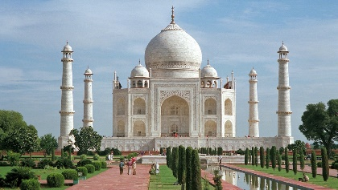 | London: Our capital City.  A study of the History and Geography of London. This unit explores the growth, key historical events and geographical opportunities and challenges of living in a large urban area.  ​ 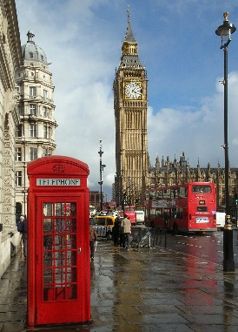 | The Romans.  An introduction to life in the Roman Empire, including; who were the Romans, life in the army, crime and punishment and life in Roman Britain. Students will develop their skills in chronology and use of source material.  ​  ​ 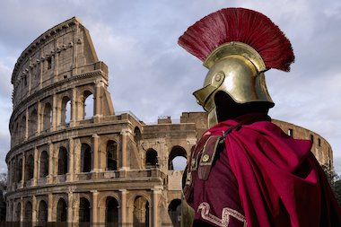 | Medieval Britain.  Students will learn about the 1066 invasion and Battle of Hastings in this history topic. Exploring castles, feudalism and the importance of the Domesday Book will develop students' understanding of the history of the UK. ​  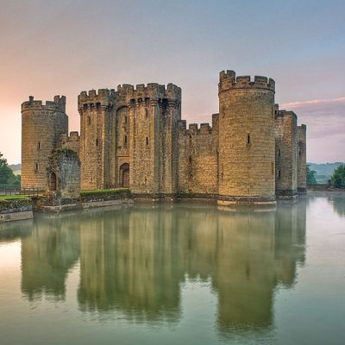 | My Local Area Investigation.  Focusing on the local area, of Stafford, students look at how the area was shaped by the Normans, visit Stafford Castle, use map skills to explain how the area has changed over time and learn about the Battle of Hopton Heath. A mix of local history and geography.  ​  | Introduction to RE and Christianity.  This topic will introduce students to a Christian place of worship. Students will learn about the artifacts in and around the church, learn about Christian music, prayer and service.  ​ 