Safeguarding Newsletter
April 2024
If you have a concern about the safety or welfare of any child at our school, please speak to:
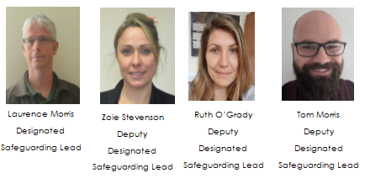
Digital Training
NSPCC offer free training to help keep children safe – it only takes 10 minutes and can be found here https://www.nspcc.org.uk/support-us/listen-up-speak-up/

Support for Children with SEND
LgFL have collated a range of resources to help support children with a range of SEND issues: https://www.lgfl.net/safeguarding/resources?field_safeguarding_topic=291&s=35

Instagram Checklist
SWGFL have produced a useful checklist to help use Instagram safely – it’s got some really helpful advice. It can be found here:
https://swgfl.org.uk/resources/checklists/instagram/#resource
Snapchat
Recent statistics show that Snapchat was used in nearly half of child sexual abuse cases. This doesn’t mean the app shouldn’t be used, but it is useful to know the facts around it. The accompanying sheet is useful for this – it can also be found here, along with many other online safety resources: https://ineqe.com/safeguarding-hub/online-safety/

Self Harm
Young minds have a very helpful site explaining self harm and strategies to help:
https://www.youngminds.org.uk/young-person/my-feelings/self-harm

Financial Exploitation
The popularity of the online gaming and social media worlds among school aged individuals can make pupils particularly enticing victims for criminals. The danger of financial exploitation among this age group can also extend its tentacles into the real world. Read more here:
https://www.childrenssociety.org.uk/what-we-do/our-work/child-criminal-exploitation-and-county-lines/financial-exploitation

Safeguarding and promoting the welfare of children is everyone’s responsibility. Everyone who comes into contact with children and their families has a role to play.
Keeping Children Safe in Education 2023

