Safeguarding Newsletter
February 2024
If you have a concern about the safety or welfare of any child at our school, please speak to:
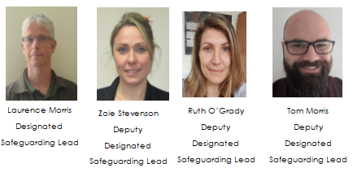
Parent Talk
This is a website from Action for Children which offers advice on a range of issues such as school refusal and healthy eating:
https://parents.actionforchildren.org.uk/

County Lines Awareness
St Giles Trust are running an awareness session for parents, carers and grandparents on 29th February 10.00-11.00
Click this link to book:
https://www.eventbrite.co.uk/e/county-lines-session-for-parents-guardians-and-carers-tickets-809050159807?aff=oddtdtcreator

Internet Watch Foundation
Increasingly, young people are being contacted in their own homes on online platforms and apps and asked for sexual pictures and videos, while their parents and carers are totally unaware.
The Internet Watch Foundation have produced resources to support families with this issue:
https://talk.iwf.org.uk/

Ben Kinsella Parent & Carer Workshops

The Violence Reduction Association has funded two Ben Kinsella awareness workshops for parents and carers on Gangs, Exploitation and Knife Crime. The sessions will take place on:
Tuesday 12th March, 18:00pm-19:00pm
https://benkinsellatrust.beaconforms.com/form/6b95850f
Monday 18th March, 19:00pm-20:00pm
https://benkinsellatrust.beaconforms.com/form/557fff12
(Click on the link to book)
The sessions will cover:
An understanding of gangs, what they are, do, how and why
Language and slang
County lines, Child exploitation, signs and stages
Online risks for young people, social media
Why exploited/at risk children might resist help and how to overcome this
How we can prevent exploitation/knife carrying as parents and as a community

Doxing
In recent years, the practice of doxing has made considerable headlines within online circles, particularly on social media as well as in gaming communities. In short, it is a practice where individuals or groups expose and publicise private information about a person on the internet without their consent, often for the purposes of causing distress or creating malicious intent.
SWGFL have produced a guide about the issue:
https://swgfl.org.uk/magazine/what-is-doxing-a-guide-for-professionals-parents-and-carers/

UK Trauma Council
A series of really useful resources to support young people dealing with trauma. It is aimed at professionals, but would be just as relevant for parents and carers.
https://uktraumacouncil.org/resources?cn-reloaded=1

Safeguarding and promoting the welfare of children is everyone’s responsibility. Everyone who comes into contact with children and their families has a role to play.
Keeping Children Safe in Education 2023

