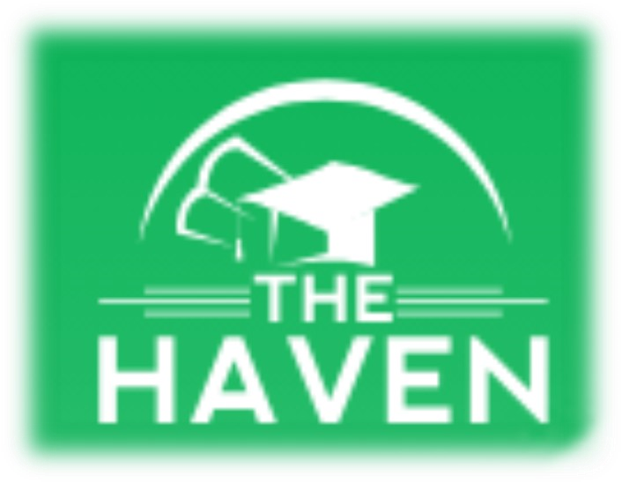
THE HAVEN SCHOOL
AUTUMN TERM
NEWSLETTER 2023
HEADTEACHER’S MESSAGE:

Where has the term gone? And what a term it has been! It has been such a pleasure to see the progress made by our students this term. Our new students
(and staff) have settled in well and now feel very much part of our school. Our existing students continue to grow and develop into the amazing young people that they are. Watching the young people support each other and build friendships is a real joy and probably the best bit about our job. I am so very proud of each and everyone of them.
I hope you enjoy reading our Christmas addition of the newsletter and I wish you all a restful and fun filled holiday period. I look forward to seeing our young
people back in school on the 8th January, well rested and ready to take on the new challenges ahead. For when it comes, have a very merry Christmas and a happy New Year!

Zoie
VOCATIONAL STUDIES:
Macmillan Coffee Event at The Haven
On Thursday 26th October 2023, our Sixth Form students hosted their own
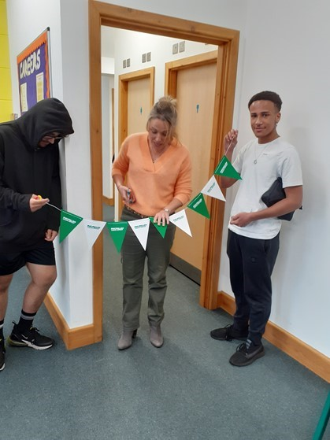
Macmillan Coffee Event. As part of the Vocational Studies qualification, they had to plan, organise and run the whole event. On the morning of the event, they set up the rooms, decorated them and ensured that everyone knew what they were doing. Sixth formers ran the event beautifully and had chance to build upon their communication and team working skills. We invited parents and carers in during the afternoon to join in with our charity event and see how hard the students had worked. It was also fantastic to see some of our sixth formers push themselves outside of their comfort zones to interact with people that they haven’t seen before and develop some key transferable skills. We also have to mention the amazing Year 11 students who also
helped on the day and joined the sixth form team without question to ensure the event ran smoothly. We managed to raise over £150 for Macmillan Cancer Research, which is the most we have raised to date. Thank you to everyone for their support and well done to the students who ran the event on the day!
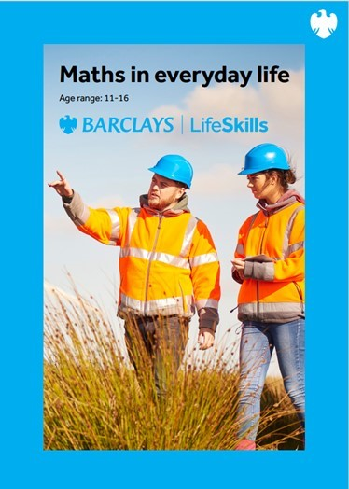
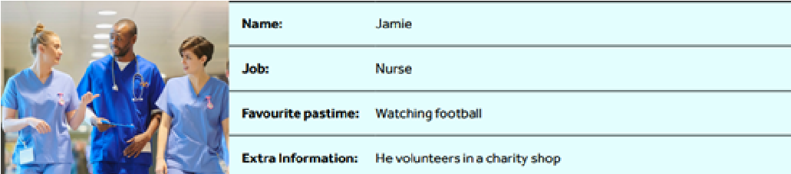
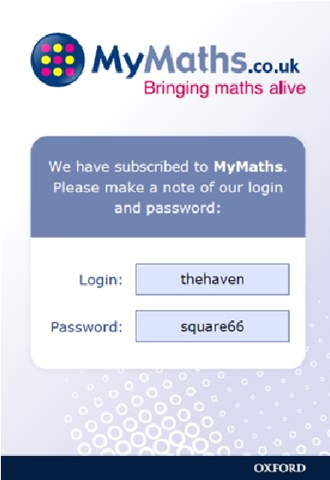
MATHS:
This term we have been helping our students to understand how everybody uses maths in everyday life and how having a good understanding of maths can help future success.
There is no ‘maths’ gene – our abilities come from learning and practising, we are not simply born with the knowledge

Ability is not fixed: everyone can improve their maths skills.
We looked at some different people’s careers and lives and decided which maths skills and topics would be used in their jobs and hobbies.
The school subscribes to the MyMaths website. This is helping to develop students’ confidence and fluency in maths. There are also lots of maths games and fun
activities to encourage students to engage more in their maths learning. Well done to all those students who are now using MyMaths and getting some fantastic results.
ENGLISH:
Key stage 3 have been reading a novel called Pigeon English. We have focused on a description of a carnival:
The air was misty. I could feel the beaten breath of hundreds of people roaring like a furious lion, the music bursting my eardrums. The sky was pitch black, only
speckles of light from where the projector was beaming up. Then it stopped.
Everything, the music, the screaming. Everything just stopped. It was the quietest moment of my life. I will never forget it. (By RH– year 8)
Key stage 4 have been improving their extended writing skills and practising how to use vocabulary and a range of language devices to achieve an atmosphere in their writing:
As I looked around, I noticed the snow glisten on Salah’s majestic hair. His shot at the goal as powerful as lightning. I could smell the beer in the air as Salah smashed the ball into the bottom left corner. Chips went flying as fans shouted.
The snow felt cold, wet and heavy on my chest. Off in the distance I could hear a chorus of, “You’ll Never Walk Alone” chants and the final whistle. I will never forget that memorable win against scummy Man United. (By AB– year
10)
PSHE:
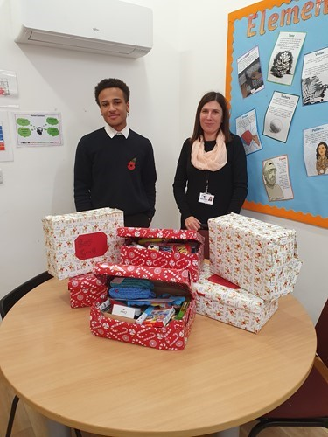
In our PSHE lessons, we have been crafting and putting together shoes boxes for The Samaritan’s charity shoebox appeal called “Operation Christmas Child.” It is a charity movement for children who are not
receiving Christmas presents because they may be living in poverty or in a war zone. We are doing this to spread joy for those children who may feel down
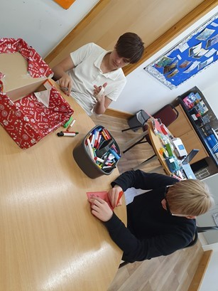
and out, and we wanted to make them happy and their lives a little bit more joyful. During this
time, we have thought about how grateful we
are for our lives where we have a roof over our
heads, food on the table and someone who loves us. Students, staff and families have
pulled together and have been incredibly generous in gifting
items for this appeal. Some examples of what we have put in the boxes include: hygiene products, small toys, winter wear, colouring books and much more. We feel we have accomplished kindness and graciousness.
DB– Year 10
CAREERS:
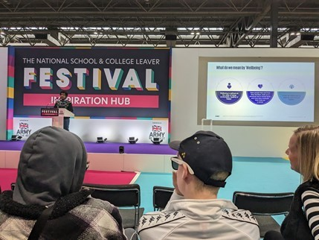
As part of our aspirational careers programme at
The Haven School, we took a wonderful group of
Y11 and Sixth Formers to visit the careers fair at the NEC on Wednesday 8th
November 2023. For many students, this was the first time that they had visited such a large-scale event with lots of other schools attending.
However, our students were
absolutely amazing and did themselves and the
school proud. They interacted with stall holders, asked questions about career opportunities and
behaved impeccably throughout the whole visit.
This was such a fantastic
opportunity for students to learn more about what
careers interest them and some great hands-on activities for them to explore. Students came
away from the event armed with information and inspired about the opportunities that were available to them.
UAS/EXAMS:
As you may be aware, this year we have started working on the Unit Award Scheme from the AQA examination board. This is a series of awards covering a variety of subjects. The aim is to recognise young people’s achievements and award them for hard work they are putting in.
So far, the following certificates have been presented:
Basic Life Support: Choking and CPR | Alfie B, Daniel B, Grace W, Jamie, Jayden A, Joseph, Tom G, Will E
Introduction to First Aid | Callum, Evea, Jayden W
Introduction to Badminton | Alfie B, Daniel B, Jamie, Josh, Pheonix
Study of a Country | Alfie B, Daniel B, Chloe B, Ace, Jamie Leon L, Lily, Maddison, Pheonix, Rayhaan, Tomas
Urbanisation | Jamie, Tom G

There are going to be more to come as more and more students complete units in
Humanities, PSHE, PE, Cooking and Art. We are so proud of what our students achieve every day, and it’s great to see them getting recognition.
We have also had a number of students sit their first ever Functional Skills exams, who we are exceptionally proud of!
ART:
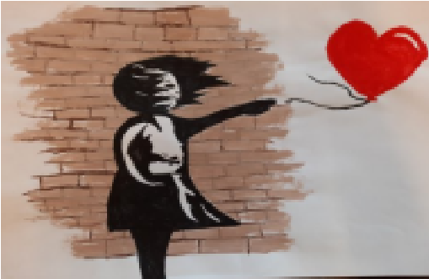
The art room has been a very busy place this term, with many of The Haven students showing their creative side and experiencing new art techniques, trying out different mediums finding out about artists from the past and the present and completing some amazing pieces of art work. Many of the
students have also achieved their first AQA Art Unit Award for
the work that they have completed. Well Done! Key Stage 3 The
Key Stage 3 students have worked with pencils, wire, water colours and a form of printing to learn all about one of the six
main elements of art, line. The students showed real resilience when creating their
continuous line animal, with wire. They have also worked together in small groups to
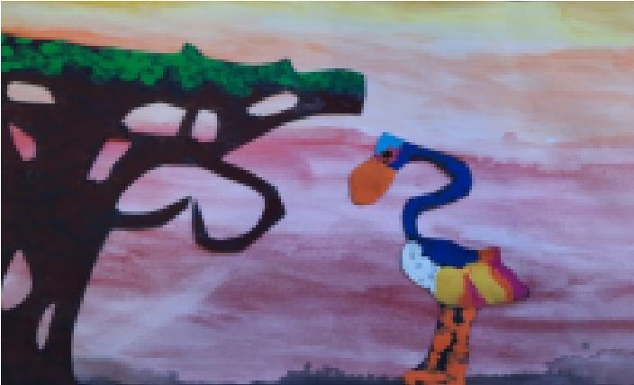
create a piece of art in the style of Picasso. They have been interested in learning about a form of art from
Africa and they have all produced their own amazing pieces of TingaTinga art.
Key Stage 4 and 5 students have learnt how to use the formal element of tone. They have discovered how to apply different types of tone, shadows and highlights to a drawing and they have produced their own fantastic still life observational
drawings using the tonal skills that they have learnt. They have also enjoyed learning about Graffiti art, when and where it first started, creating their own ‘Tags’ in Graffiti style writing, debating about whether this form of art is vandalism, or art and they have drawn and painted a Banksy painting.
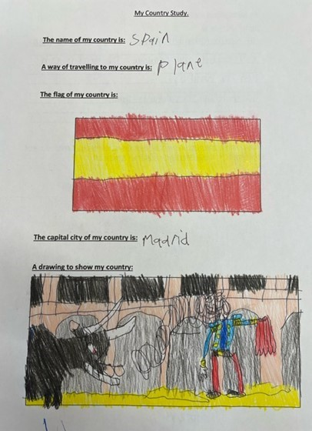
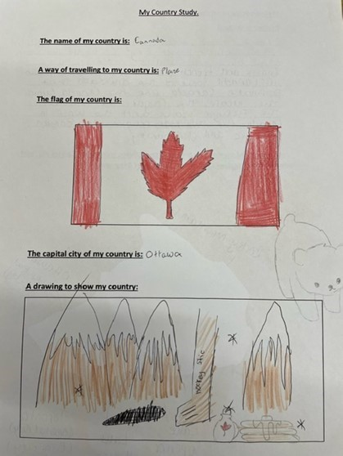
Geography/Humanities:
Key Stage 3 and some Year 10 students have been learning about a range of different History and Geography topics this term. September started with completing unit awards of a country of their choice. The different countries included Germany, Spain, Vietnam, Japan and USA, showing that students here at The Haven had a real range
of interests in different parts of the world. Students had to research the history and culture of their selected country. Well done to 12 students on completing this award. Below are Canada by MA and Spain by DB.
PE:
We are excited to share some amazing news from our PE department! Our pupils have been excelling in various sports and have achieved impressive
results in badminton and table tennis at the Stafford Leisure Centre. Also the
6th form PE group have been amazing with their weekly gym sessions; the group are also pushing each other to do more each week and always show support during the lessons. Additionally, our students have shown great
enthusiasm for football through their engagement with the Wolves Foundation and have represented our school exceptionally well in an inter-school tournament. Lastly, our dedicated BTEC group has been working tirelessly and is nearing the completion of their component 1.
Congratulations to all our students for their achievements in our AQA unit awards. We are incredibly proud of their hard work, dedication, and sportsmanship. Keep up the excellent work, and let's continue to excel in all our upcoming sporting endeavours!

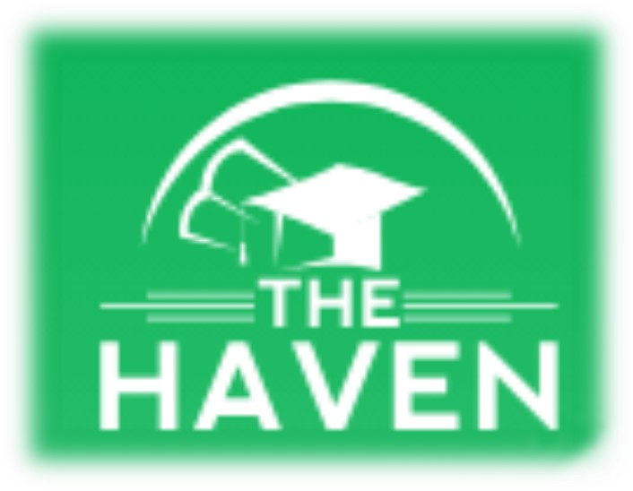
From all the staff at The
Haven, we wish you a Merry
Christmas, and a happy and healthy New Year!

