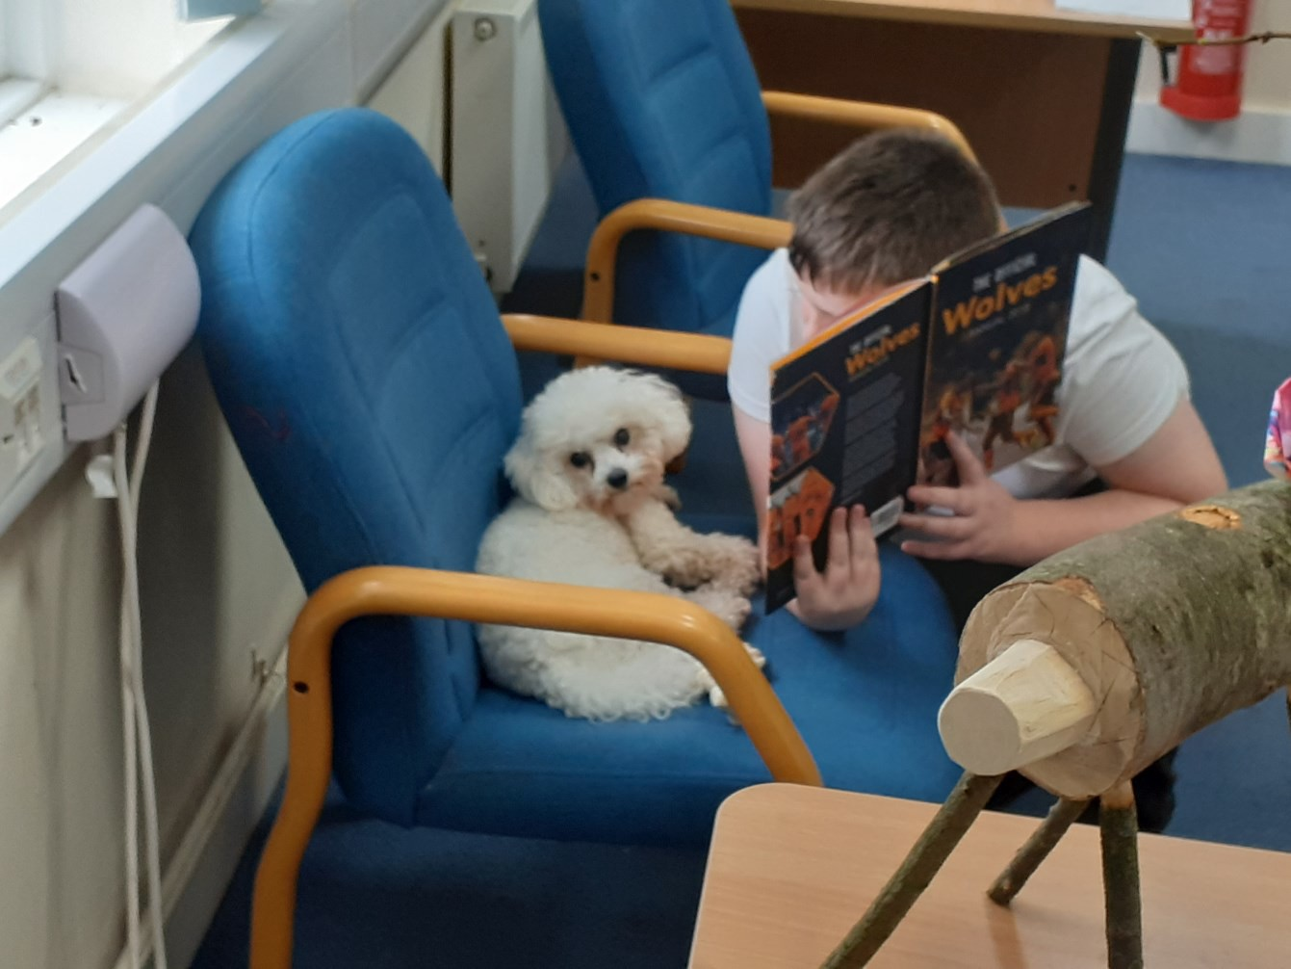
The Haven
Summer Newsletter 2021

Our school dog Coco loves sharing a good book with our students!

Headteacher’s Message

Well we made it to the summer term... and what a year it has been! I could not be prouder of our Haven community. The students and staff have worked tirelessly this year and even with that 'pesky virus' trying to hinder our plans, have triumphed. The academic outcomes that have been achieved have been admirable and I know when the students collect their GCSE results in a few weeks they will be really chuffed with their efforts. Personally, there have been many success stories for our students,
whether that be making new friends, developing the skills to better manage their
emotions, or improving their attendance, these have all been noted and celebrated. It was an absolute pleasure to read their end of year reports, they were just fantastic, and I know we have had lots of positive feedback from parents and carers regarding

This year's highlights for me.. watching new students become more confident and settled, watching our older students develop into young adults and their realisation
that 'anything is possible', the cricket and the students working as a team supporting
each other in such a positive way, the standard of Art that has been produced and that is now on display, and of course sports day!

I hope you enjoy reading this terms newsletter and I am sure you will agree, it has been a truly amazing year for team Haven! Enjoy your summer and we look forward to seeing you all in September.

Take care and stay safe,

Zoie Stevenson
Headteacher
The Haven School

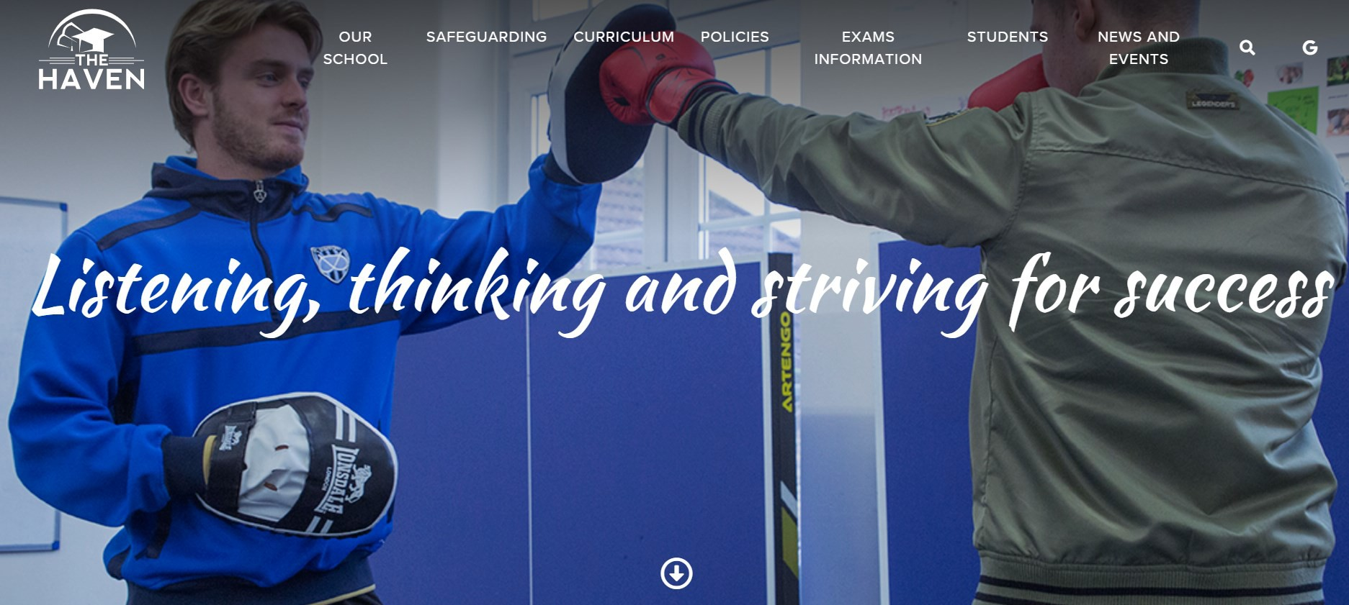
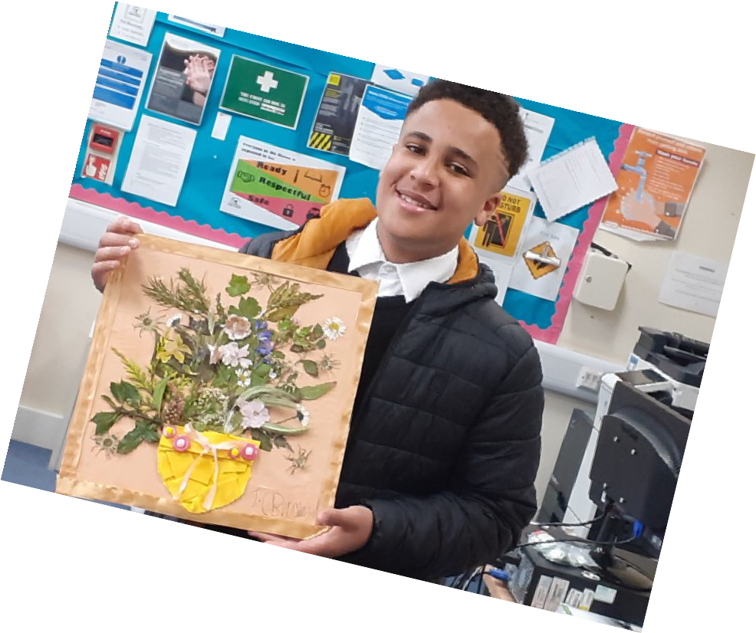
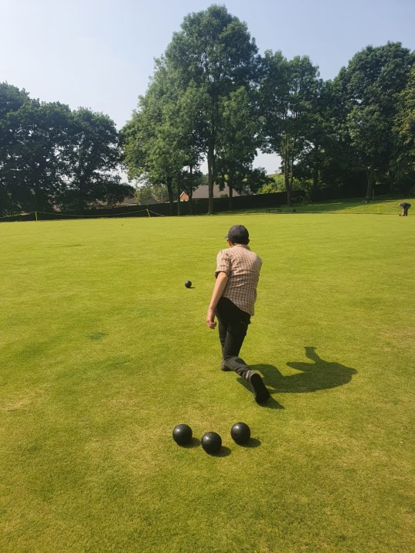
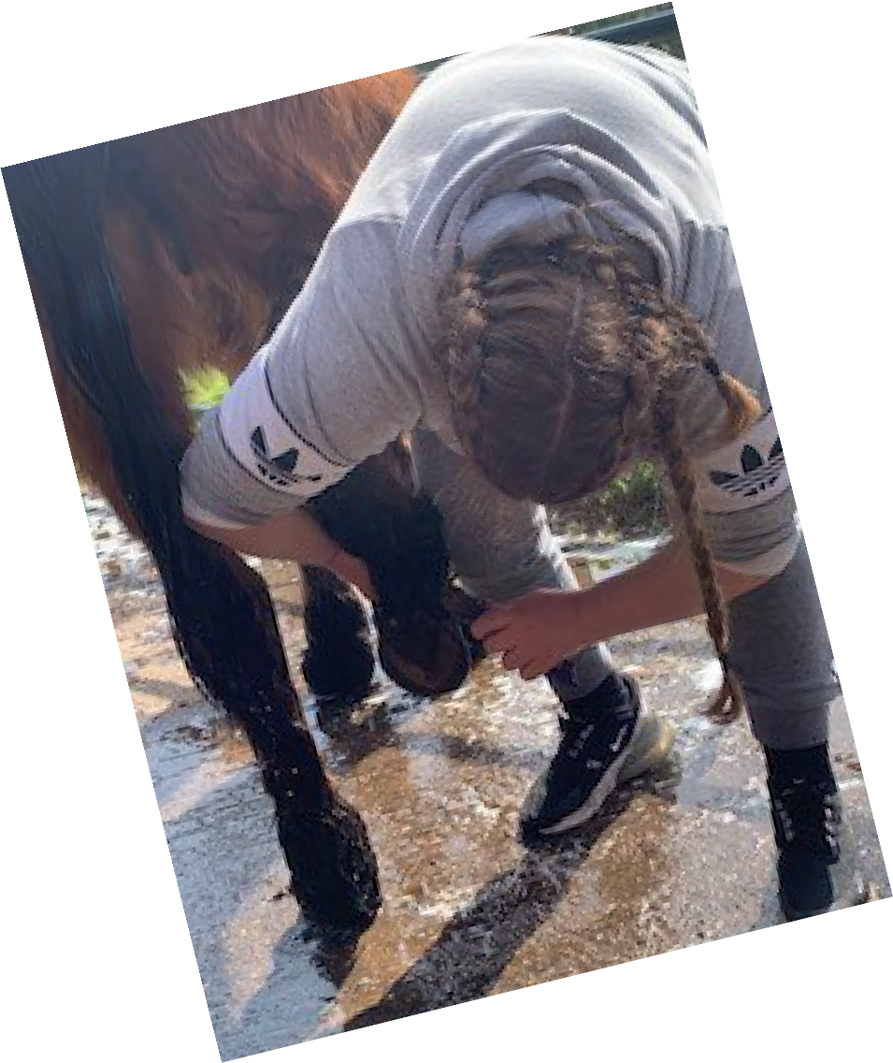
We hope you enjoy reading through our newsletter and get a flavour of what life is like for our students at The Haven.

Again, this year has been disrupted by Covid 19 including lockdowns and self-isolation. However, our students have demonstrated resilience, determination and a strength of character they can be really proud of! We certainly are and this newsletter is a
celebration of all they have achieved.

GO HAVEN!
Mrs Gould

To get more information about our school please check out our website at:

https://www.thehavenschool.com/

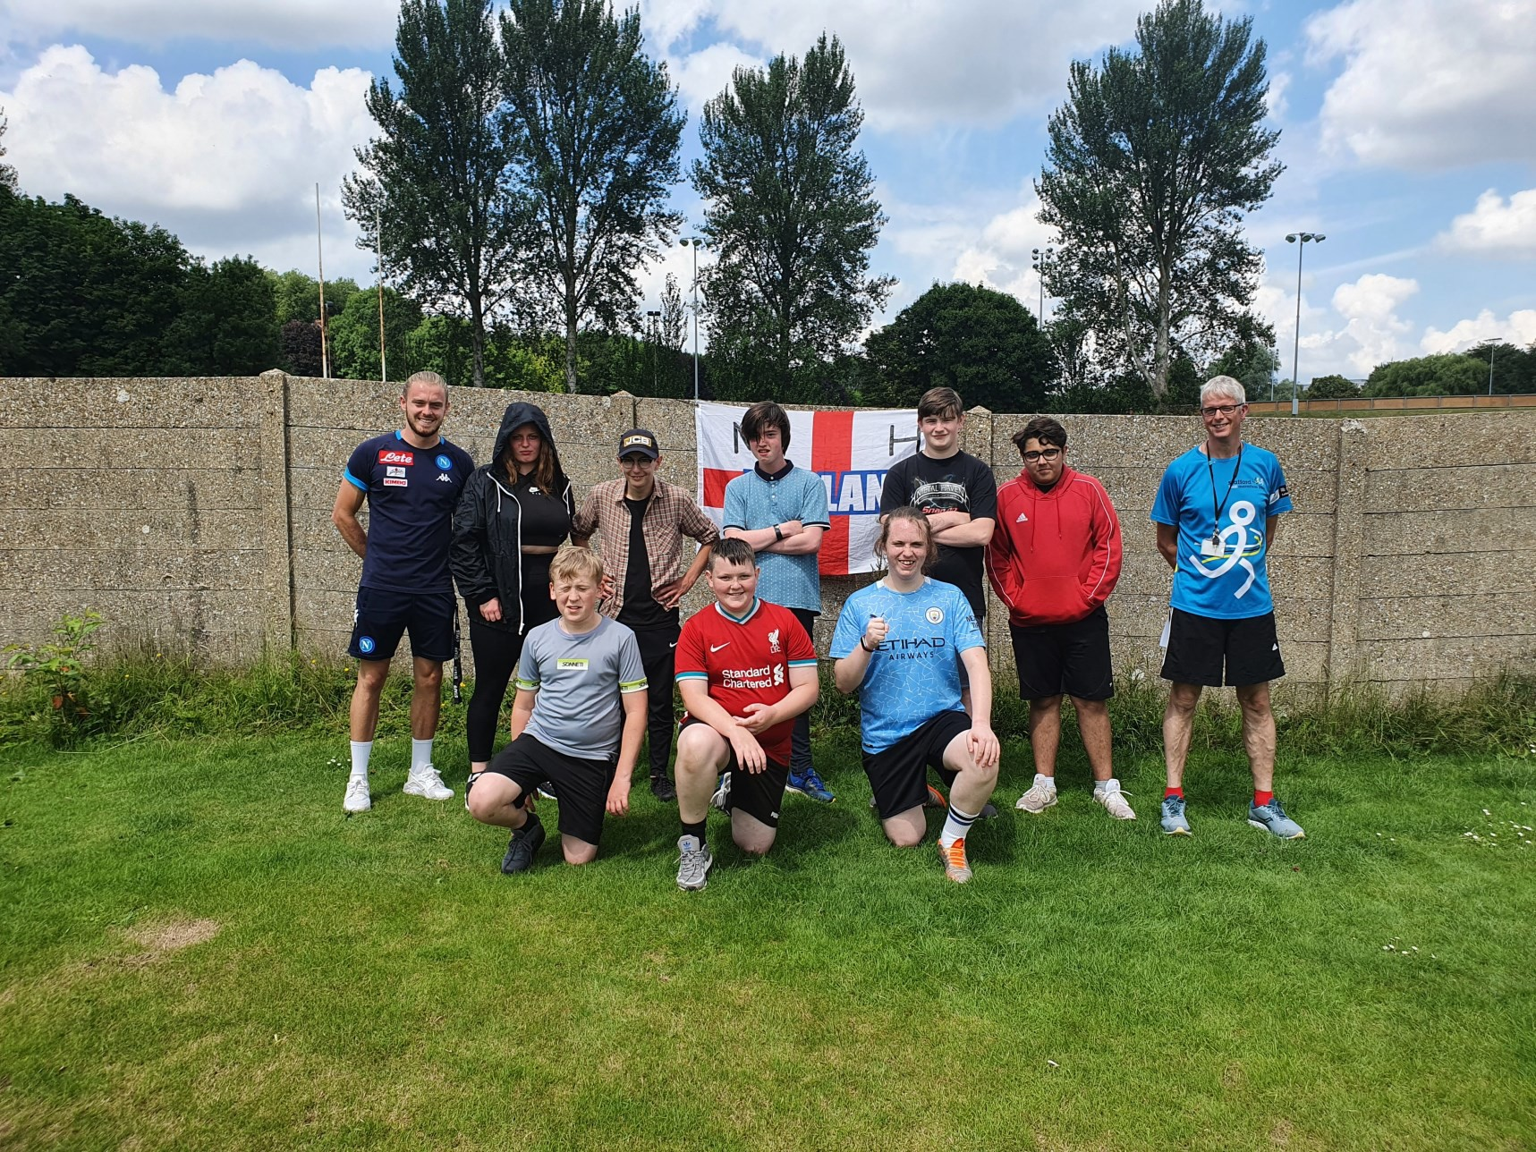

At the end of a phone call about whether we might get involved with some
cricket competitions next year, we were asked, “Do you fancy entering our Key Stage 4 tournament?”
“Sounds great – when is it?” “The day after tomorrow.” “Er…ok, we’ll give it a go.”
And so The Haven Cricket Club (THCC) was formed. We found eight students who said they would play and arranged a 40-minute training session. Nothing could go wrong.
On the morning of the tournament, we discovered we were one player short. Fortunately, Alfie (Y7) was brave enough to step up, despite most of the play- ers being 3 or 4 years older, and we set off to Newcastle and Hartshill Cricket Club.

THCC arrived and saw four other teams, some of whom had kit and all of whom looked like they knew what they were doing. It was too late to back out, so after a quick briefing from Staffordshire Cricket, we went into our first game.
We batted first, and the nerves eased a little as Linus hit the second ball out of the ground and scored 36 from the first twelve balls! We went on to win com- fortably and found out a lot about ourselves along the way: Jack bowled really accurately and hardly give any runs away; Hayden and Jayden not only rhyme, but batted really crisply, scoring repeated boundaries; Alfie (Y10) remained very calm under pressure and made great decisions. We looked like a team.
The batting order and roles were tweaked as we went through the second and third games. Again we won comfortably, despite both schools being experienced and well-organised. Game Two saw the champagne moment of the day when a batter drilled a ball that looked destined for 6; as it passed Bailey, he appeared not to be even looking at it, but stuck out a hand to take a seemingly impossible catch. Pandemonium!
THCC were left with one final game, against the other undefeated side. The win- ner would claim the title. Very few of our players had ever represented their school at sport before, and certainly not in as high-pressure a game as this. The opposition were a PRU and physically much bigger than our team. It would have been easy to be intimidated, but our team showed real determination, with Beth showing real grit in her batting. We posted our lowest score of the day, mainly due to some excellent fielding. We began to bowl, knowing that we needed to
take wickets to keep the score down. Despite our best efforts, including Alfie (Y7) who was now untouchable as wicket keeper, they had too much power and we ended up losing by a tight margin.
Coming second overall in our first ever sports tournament was a major achieve- ment. Whilst every player made great individual contributions, the most impres- sive element was how well the team played together. Everybody supported each other and nobody blamed anyone for mistakes. They were a credit to themselves and the school; staff who were lucky enough to be there (and those back at
school receiving text updates!) were incredibly proud. In fact, following such an impressive display, we have been invited to join the North Staffordshire Special Schools Sports Association, so this was the first of many such events. Watch this space…
Mr L Morris

This term the Social group went on an outing To Birmingham:
The group planned the trip themselves; checking train timetables, places they wanted to visit, cost of train fares and checked the maps to gauge distances:

‘A sunny Wednesday in July saw a group of sixth formers together with Miss Seaward and Mrs Westwood ( Ethel) take the Cannock train at 10:30 to Birmingham, everyone was very hyper. We set the itinary of where we wanted to go: hmv, manga store, disney store, marvel and dc store. Two student had their new bank cards with them and keen to zap them for a purchase.

Train pulls into station and we are off, first call Starbucks to revive Mrs Westwood. A
further two stores in the bullring with some nice purchase. Someone spied hotel choc- olate mmmm the smell drew us all in.

Time flew by as we made out way to the Manga Store. This store was an Alad-
din‘s cave of goodies’ …further purchases the new cards were hot! . Next stop the DC and Marvel shop. Wow we were all Bowled over. Time was running out and
tummies rumbling so last stop five guys.

We legged it back to new street just caught the 2.45pm back to Cannock Station.
Lots of laughs on the journey back. A truly fab day.’
From Jessie Jack, Ellie-Mae and Bradley (Mrs Westwood and Miss Seward)

Escape Nation:
"6 seconds to get out ... quick before we're locked in!" Did we do it ... affirmative, affirmative!

If anyone had asked what I thought about being locked in an 'escape room' with 4 students and an English teacher I might have said, " You have got to be joking...right."

But I really can't tell you the last time I enjoyed an hour so much!

This was something that I think only one of our team had done before, the rest of us were trying to be brave but wondering what we had we signed up for? So ...
let me say this to anyone deciding to have a go at this type of activity: if you
weren't a team before you started you will be at the end. If ever you needed to work together- this was it! The English teacher and I relied so heavily on the
expertise of our very space savvy students! The skills needed to get out of the fail- ing spaceship we had in abundance - thank goodness! We had code break-
ers, padlock experts and last but not least torch holders. When asked after we had escaped - did I say with 6 seconds to spare? - would we all do the again the resounding answer was YES! In the infamous words of Dr Spook, " It was fun Jim, but not as we know it." Work that one out team??
Mrs Gwyther

Over this academic year, students have developed their creative skills within their Art lessons and there have been numerous projects on the go that the pu- pils have been working on.

Recently, some students have looked at the works of Picasso and encapsulated the surrealism of his work, into their own designs.

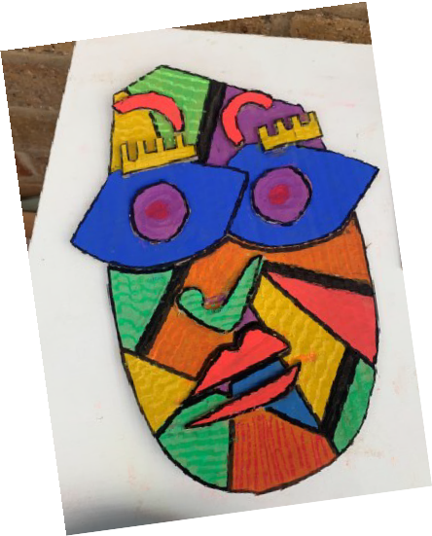
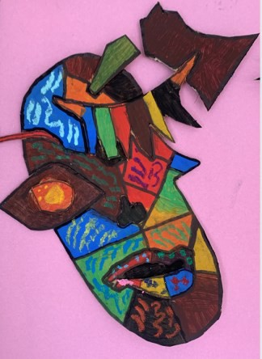
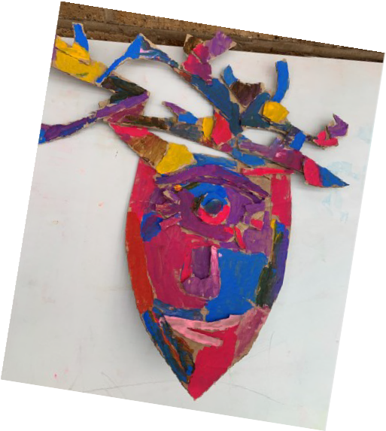
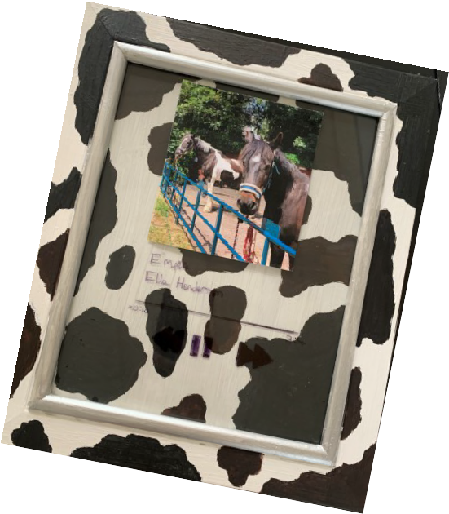
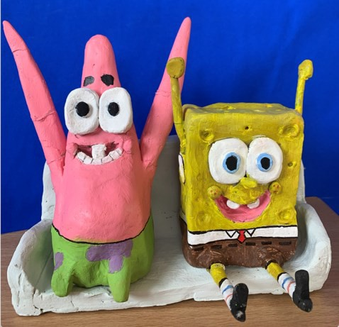
During the summer term, students have really enjoyed evolving their own passions and hobbies into their design work. One particular student looked at her adoration of horses and horse riding. She looked at the patterns and colours of each horse to
emulate through painting onto a picture frame.!

Miss Baker
There are some active learners who enjoy working in different
mediums. One student has really enjoyed
working with clay throughout the year, refining his skills. Over a few weeks, he managed to produce this excellent sculpture of Spongebob and Patrick!

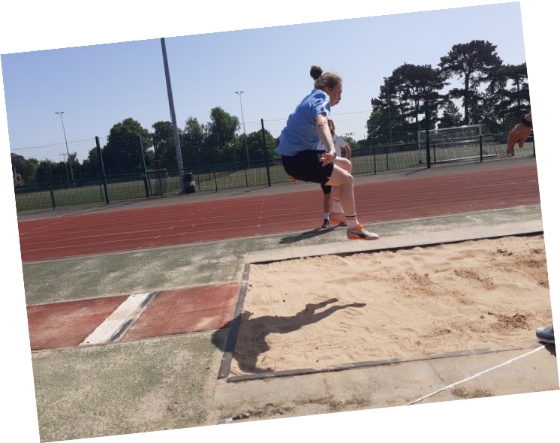
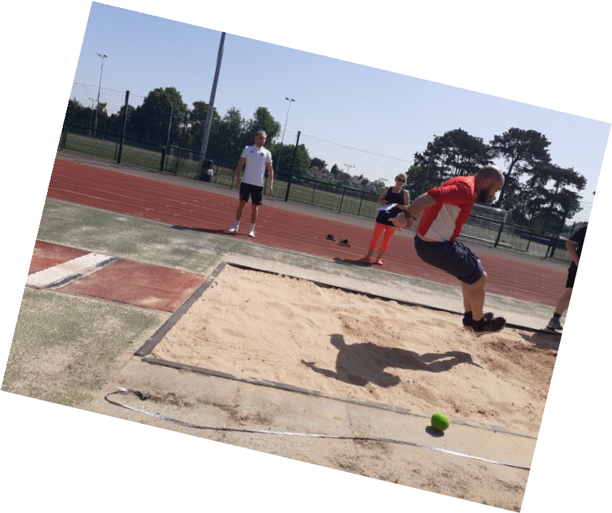
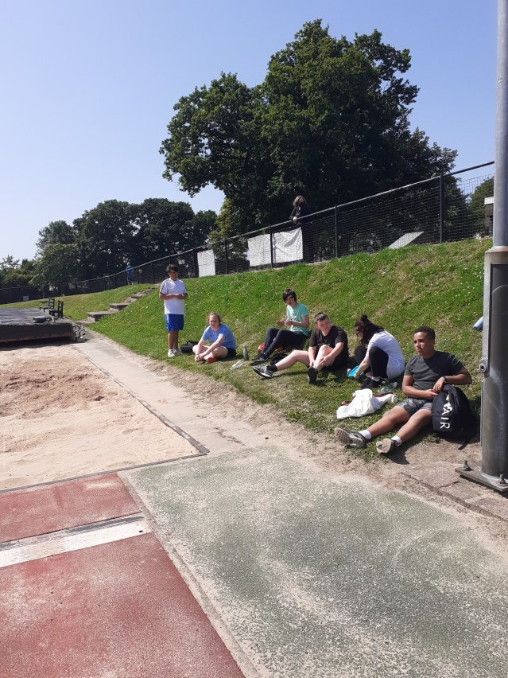
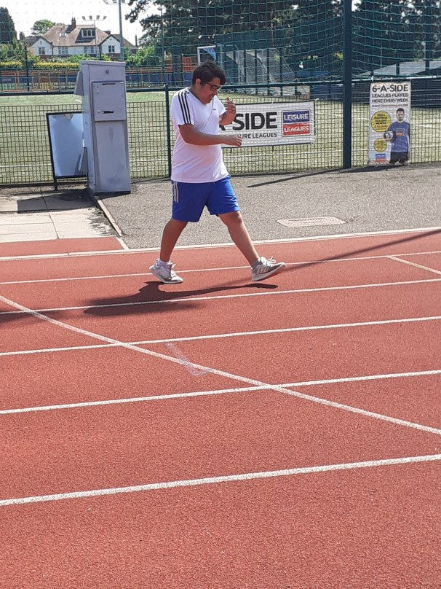

This year was The Haven’s first sports day on an official track and included field events!

We started with the discus event ,which went extremely well considering not many of the pupils had thrown a discuss before! The furthest thrown was a massive 20m!

After came the track events; the pupils started with the 400m race, then 200m, 100m and a then a short 50m to finish. Every pupil did amazingly well and gave 100% of their best!

Mr Marshall

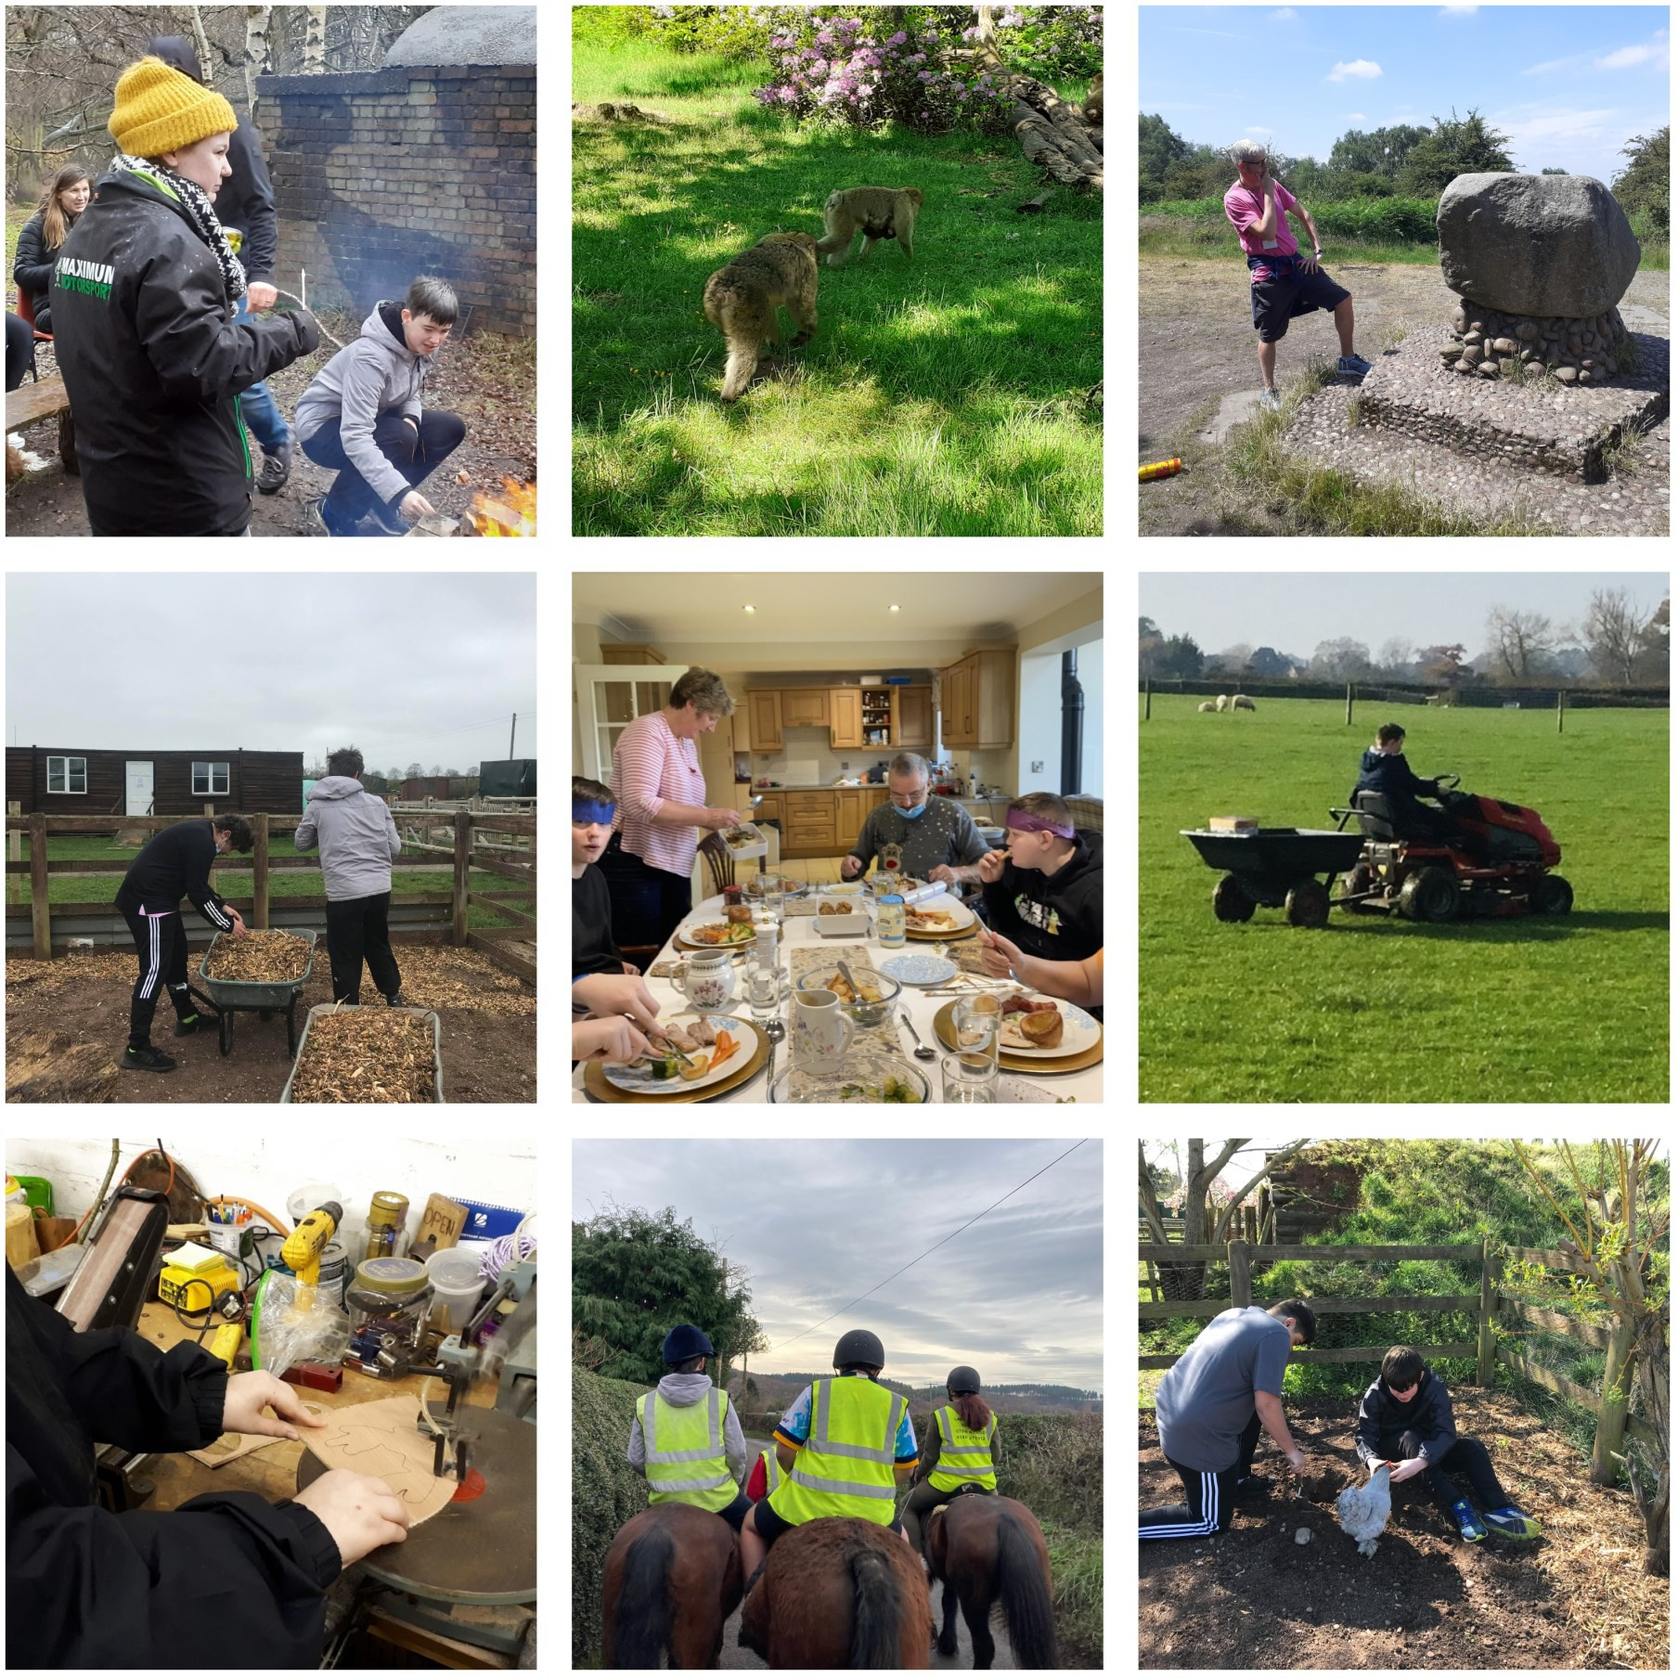

Many of our students are lucky enough to participate in alternative provisions and activities which are beyond our school site. These enrich and broaden our students’ learning experiences as well as giving them opportunities within a different environment in which to practice their knowledge and skills in a
more practical way.

Some of our provisions this year have included Bushcraft, Horses, Chase Aqua, Outdoor Education, Healthy Living and the Farm. Take a look at some of the things they have been up to…

Leavers
2021

We were sad to say goodbye to some of our students who are leaving us this year to follow their own pathways. We are very proud of them all and know they have all got exciting adventures planned ahead.

Well done– we will miss you and we look forward to hearing how you are getting on so please keep in touch.

Have a great summer everyone!

