Safeguarding Newsletter
October 2023
If you have a concern about the safety or welfare of any child at our school, please speak to:
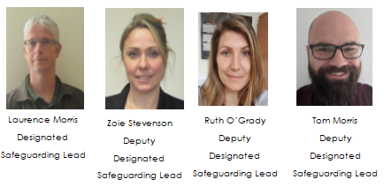

TALK
The Internet Watch Foundation have helpful advice about how to talk to a child about online sexual abuse.
https://talk.iwf.org.uk/talk-to-your-child/

Child exploitation – Northants Safeguarding Board
This is a video about signs of criminal exploitation of children. The contact details at the end are only for the Northampton area – if you are concerned about a child in this situation, please either contact school or ring the Staffordshire Safeguarding team on 0300 111 8007.
https://www.youtube.com/watch?v=IpgqEyRGggA

Vaping advice
As you will know from messages home this term, there are increasing concerns about the impact of vaping on young people; hence, why we have banned it in school. This site is aimed at parents and carers who are worried about their child’s use of vapes.
https://parents.actionforchildren.org.uk/behaviour/challenging-behaviour/im-worried-about-my-child-vaping/

Knife and Gun Crime
Childline have produced a useful page for those who are concerned about the impact of knives and guns.
https://www.childline.org.uk/info-advice/bullying-abuse-safety/crime-law/gun-knife-crime/
Grooming
‘Not in Our Community’ was set up in Humberside to provide resources to tackle grooming – it has all sorts of help and advice for supporting young people.
https://notinourcommunity.org/

Harmful Sexual Behaviour
Shore was launched in 2023 to provide a safe and anonymous place for young people to get help and support. The aim of the website is to prevent harmful sexual behaviours among young people.
https://shorespace.org.uk/about-us/#
It’s for anyone who:
- has questions about healthy sexual relationships
- wants to change their own behaviour
- is looking for reliable information to help them respond to someone else’s behaviour

Worries About War
UNICEF have produced a factsheet to support conversations about major world events: https://www.unicef.org/parenting/how-talk-your-children-about-conflict-and-war?utm_source=Unicef_UK&utm_medium=Email&utm_campaign=email_rrsa_campaign%20name

Hollie Guard
This is an app that has been developed to keep people safe when out and about. It has a lot of useful features that your child (or you) might want to use in certain situations when they/you feel unsafe. There is a premium (paid) version, but the basic version is free and has a lot of useful features.
https://hollieguard.com/#features

Safeguarding and promoting the welfare of children is everyone’s responsibility. Everyone who comes into contact with children and their families has a role to play.
Keeping Children Safe in Education 2023

