The Haven School

0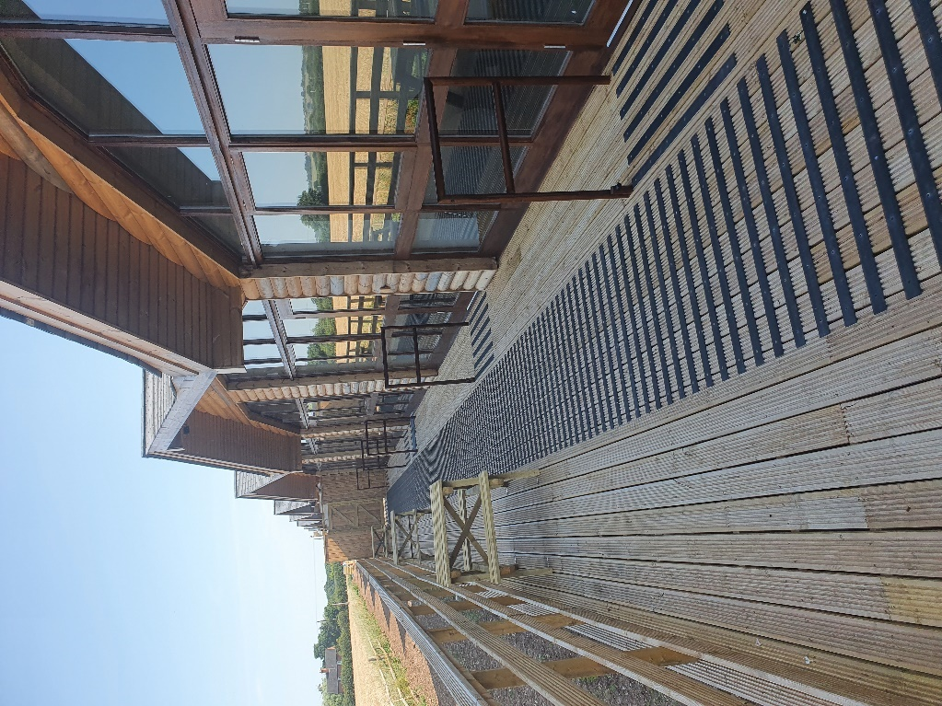

Newsletter : Summer 2022

Headteacher’s message:

Wow... where has this term gone? I cannot put into words how proud I am of our students and staff. Everyone has made so much progress and achieved so much in a year where things have still not felt ‘normal’.   However, against adversity the Haven values and ethos have prevailed and we have had yet another fabulous year.

There are so many personal highlights for me, so I will try and summarise.....

Our young people taking up horse riding, from the first week not being able to mount their horse, to overcoming their fears and wining rosettes and passing accredited courses in equine studies.  The work young people have done at bushcraft, the way they have cared for the environment and developed all manner of skills in engineering, ecology and team work. Our amazing sports teams... so proud to see them take part, support each other and work as a team.  Other schools we visit constantly praise our students for their ‘sportsperson’ ship... we have done pretty well too! The students work at the farm has amazed me, the lambing and general sheep husbandry they can now all do astounds me.  On Outdoor Education students have achieved climbing and trampolining qualifications and have even been kayaking... for some of our students these were new experiences, but they have developed the confidence to try new things and have seen that they can be successful.

Academically there are so many achievements, more students this year sat nationally accredited examinations than ever before.  Not only students in Yr 11/12 and 13 but our Yr 10 students have also sat exams.  For some of our students this was their first formal exam ever..... you would never have known as they all faced this period with determination and positively.  Socially, we now have more and more young people who want to engage with others and enjoy the company of their peers where in the past they have found this their biggest challenge.   Social activities such as bowling and trips to Birmingham have helped massively with this.

I could go on.... However, what I need to finish with is that all of this fabulous work and achievement would not be possible without the support of our parents and carers.  Thank you for your continued support.  Have a lovely summer and look forward to seeing you all in September!

#Ilovemyjob.

Mrs Stevenson

This year at the Haven PE has got back into full swing with Covid restrictions easing up. In practical PE we started the year with basketball and as we went into the winter months we sheltered in side and started to learn about different martial arts. These included Shotokan karate, Muay Thai, Taekwondo and boxing.

As we entered the new year we started to focus on health and fitness, which a lot of pupils engaged in very well. We looked at different ways of training the body and how to have a well-balanced diet.

When the weather started to warm up we started to go back outside and take part in sports such as football and cricket. These are the favourite sports/topics for the pupils which has been evident by their excellent engagement levels.

In addition to our normal PE at the Haven we have started to work with the Wolves foundation. These sessions have been every Monday afternoon with a mixed group of Key Stage 3 and 4 pupils. The practical sessions have been based at Aldersley stadium and the theory sessions have been based at the Molineux stadium in either the media suite or one of the executive boxes.

A great year – well done everyone!

**Mr Marshall**

English

This year in English we have been following a number of different routes. With so many students successfully passing English Language GCSE last year, we began English Literature for the first time. Students studied ‘Macbeth’; an anthology of poems about war and conflict; and ‘Blood Brothers’ by Willy Russell which a group of us also went to see at the Birmingham Hippodrome. We are waiting to see their results, but have already moved onto the AS Level English course, starting with ‘The Great Gatsby’.

The other Key Stage 4 students have either been working towards GCSE English Language, Functional Skills or both. During the year, three achieved passes in Functional Skills Level 2 which was a great achievement, and we expect to hear more great results this Summer.

Younger students have studied a variety of topics including poetry and non-fiction texts. More recently, we have been working on ‘Noughts and Crosses’ by Malorie Blackman, allowing students to explore complex ideas about race both in the novel and the TV adaptation.

**Mr Morris**

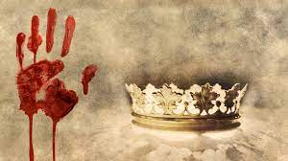

Maths

**KS4 and KS5**

Throughout the year some of our KS4 and KS5 students have been very busy practising a range of topics which are essential for everyday life, for example, time, travel, money, shopping and work-related tasks. This has prepared them for their functional skills maths exams, which they have been able to sit at different points in the year. Others have been following a revision programme to prepare for the GCSE maths exams. They have concentrated on improving their skills in the six topic areas: number, algebra, ratio and proportion, geometry and measures, probability and statistics. All students have completed some fantastic work on past GCSE and functional skills questions. Well done to everyone who has taken maths exams at some point during this year. You have all worked very hard.

**Mrs Ratheram**

Information Technology

**New Qualification!!!**

This year saw the introduction of the Functional Skills Level 1 and 2 ICT. This is a completely new qualification to the school and this year we had 5 pupils sit their Level 1 qualification, which is a massive achievement. The functional skills qualification focuses on the use of Microsoft Office using programmes such as Excel, Word, Publisher, and Outlook. Whilst looking at different qualifications, We decided that the Functional Skills qualification is an excellent fit for pupils at the Haven, as not only does it provide IT skills for life- for example using software to assist with formal writing and household budgeting- it also provides skills that many employers look for. Nowadays, 82% of jobs require the use of Excel! In September, we will have pupils starting Level 1 and 2 programme, which is really exciting.

In the meantime, I hope everyone has a great summer.

**Mr Morris**

Vocational Studies

It has been very exciting to see BTEC Vocational Studies, as a subject on the timetable for Year 11 and 6th Form students this academic year. It has been the first year that students have had the opportunity to take this subject at The Haven. Many of the students have experienced a number of the units taught over the past year. The idea behind BTEC Vocational Studies' units is that students will develop skills in areas such as organisation, communication and teamwork. Qualities that will help them in further education or in employment in the future. Units that have been covered since September have been ' Contribute to Running an Event'. The pupils that completed this unit enjoyed organising and putting on a Macmillan coffee morning for staff and other students. This was enjoyed by the whole school, 'Being Part of a Team' was a unit where the 6th form students worked together and ran a fun Christmas event for the school. They showed amazing teamwork! 'Understanding Personal Health and Hygiene' covered a lot of different aspects from healthy eating, benefits of exercise to experiencing a range of techniques to keeping a healthy mind and learning about the importance of sleep. This unit also encouraged students and the teacher to complete well-being walks each week. A great form of exercise for both the body and mind. These walks are still continuing for both the teacher and some of the students. Other units that have also been taught have been 'Planning for the Future' and 'Handling Money'. We are looking forward to more students choosing to take Vocational Studies next academic year.

**Mrs Maxwell**

Art

This year, everyone has produced some incredible art work, which they should be so proud of. We have worked on our own faces inspired by Picasso, got our hands messy and had a go at some paper mache to make some sea creatures and drew many, many lines to create some fantastic abstract art. Everyone has worked so hard and their incredible imaginations have shone through throughout the year.

**Miss Francis and Miss Seward**

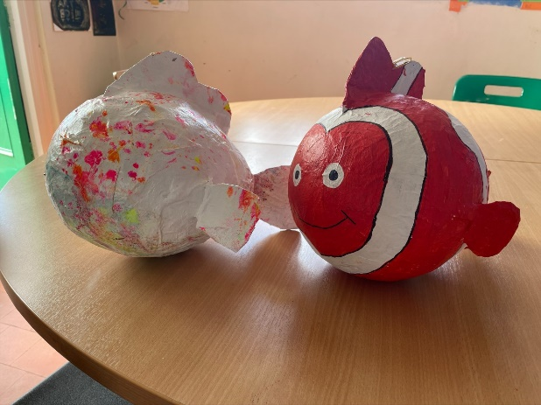

Outdoor education

This year, Outdoor Education has been a year of experiences.

 The year started off heading to ‘Awesome Walls’ in Stoke, where pupils completed their Level 1 NIBAS Award. Students had to complete a series of climbs while also learning some theory work about different holds. They did all of this whilst also channelling their inner spiderman. After Christmas we were off to ‘Tumbling Trampolining’, where different levels where complete by pupils. Some were flipping around, others were learning the fundamentals, but everyone did so well. Next up was swimming at Wolverhampton Leisure Centre. We had our own private pool and an amazing instructor. Pupils achieved levels in swimming in distances of varying degrees. Pupils were also given lesson on personal safety in water and how to save someone if they need help in the water. This last half term has been a half term of new experiences to try something new. We have been to a water park, a theme park, adventure golf and last week we headed off to Chase Water to have a go at Kayaking. This ended up turning  into a jumping in session as the weather was just so beautiful.

**Miss Francis and Mr Simpson**

PSHE

Our PSHE learning threads through our entire curriculum. Students have discrete lessons during the week, but also engage in PSHE during assembly, form times, social times, drop-down days and during all other subjects. This year we have had a focus on Learning Styles, Diversity and rights in the workplace, LGBTQ+, British Values, First Aid and Healthy Relationships both online and in the real world.

**Mrs Gould**

Finally…

We are looking forward to learning in our new additional premesis at Dunston!

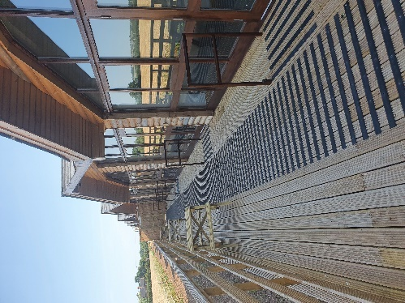 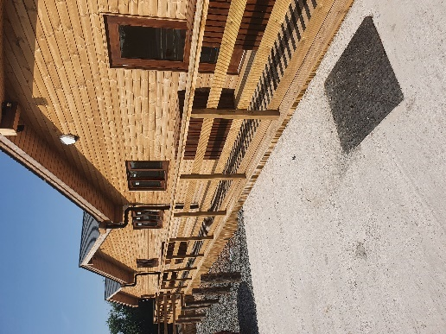

Good luck on your future adventures to all those students leaving us this term! We look forward to see everyone who is staying on in 6th Form and welcoming those new students who are starting with us in September! Enjoy your summer!

**The Haven Team!**  